Dropcam User Guide

National Geographic Exploration Technology Lab

Version 1.2

2/27/2019

## 

Table of Contents

**Revisions** **3**

**Contact Information** **4**

**Expedition Planning** **5**

Travel Checklist 6

**Preparing for Deployment** **8**

Conditions at the Deployment Site 8

Deployment Procedures 8

Deployment Timeline 8

Mission Planning 9

**Do’s and Dont’s** **9**

DO 9

DON’T 9

**Deployment log** **9**

**External attachments** **10**

Flag 10

Separating the sphere 11

Sealing the sphere 12

**Set Up Procedures** **13**

Function Test 13

Check Beacon and Argos 14

Check Camera HD 14

Programming Mission 15

Inspecting seal and cabling for damage 16

Checking Vacuum 16

Attaching Burnwire and GTR 16

Prepare Anchor and Bait 16

**Deployment** **17**

Using the GPS 17

**Recovery** **17**

Using the VHF receiver and Yagi antenna 17

**Completing the Droplog** **18**

**Data Download** **18**

Downloading Video Data 18

Downloading Pressure and Temperature Data 19

Plotting Pressure and Temperature Data 20

**Standard User Kit Packing List** **24**

**Dropcam Illustrations** **26**

**Cables** **27**

**Troubleshooting** **28**

Problem: Teraterm is showing nonsense characters. 28

Problem: When I open Teraterm, I don’t see any response from the Dropcam, even though the magnet is out and the USB cable is plugged in. 28

Problem: Error occurs when opening Tera Term “Cannot open COM. Not found.” 28

Problem: Tera Term shows [disconnected] 29

Problem: Tera Term showing “Bad Command”. 29

Problem: Camera continually disconnects from USB at irregular intervals. 29

**Procedures** **30**

Connector Greasing Instructions 30

Checking the COM Port and Saving the Settings 30

Configuring the Serial port settings 33

**Knots** **35**

## 

## Revisions

|  |  |  |
| --- | --- | --- |
| Date | Initials | Revision |
| 20180810 | AT | Created |
| 20181002 | AT | Added minor fixes to checklist, added table for task times |
| 20181002 | JE | Burnwire GTR instructions (tug on release loop)  Packing List update (toothbrush to clean)  Dropcam checklist/deployment (flip up and secure camera protector)  Note Argos tester finicky-ness  Close teraterm if launching labview for temp data download. |
| 20181203 | AT | Added travel checklist |
| 20190227 | AT | Added flag attachment and sphere separating procedures |
| 20190816 | JE | Revise guide in all the ways to reflect the changes made to the platform and software. |
| 20190816 | JE | Update checklist to reflect checklist (pre/post, and deploy/recovery) |
| 20190818 | JE | Cleaned outline for easier navigation |
| 20190819 | JE | Incorporate Cheat Sheet information-incomplete |
| 20190927 | JE | Complete cheat sheet incorporated |
|  |  |  |
|  |  |  |
|  |  |  |

## Contact Information

Alan Turchik

Product Development Manager, Project Lead for ExTech Deep Ocean Exploration

[aturchik@ngs.org](mailto:aturchik@ngs.org)

+001-202-807-3311 (9AM - 5PM EST; 1PM - 9PM GMT)

+001-510-299-4072 (anytime, EMERGENCIES ONLY)

Jess Elfadl

ExTech Equipment Coordinator

[jelfadl@ngs.org](mailto:jelfadl@ngs.org)

+001-202-807-3508 (9AM - 5PM EST; 1PM - 9PM GMT)

## Expedition Planning

### Logistics

You will need to arrange a few things to prepare for your dropcam expedition.

* Permits
  + This should be addressed as far in advanced as possible
  + It is recommended that the User/Collaborator handle permitting
    - NGS will be able to support with any documentation or technical specifications needed addressed.
* Equipment Handling
  + Will you be picking up the equipment? Needing the equipment shipped? Or having an NGS field support staff bring the equipment aboard?
* Deployment amount
  + In expedition planning, it should be addressed how many deployments you will be targeting for appropriate material planning.
    - Ex, Avg. 5 per week with a dedicated crew member on a 3 week cruise
* Deployment location priorities
* Sand (used for the anchor)
  + 10KG per drop
* Bait (oily fish is recommended)
  + 1KG per drop
* Assign DOEX#### ahead of locations to be able to complete the deployment log and generate deployment IDs

### Software

Once deployment locations have been defined, address pre-programmed mission parameters that will best suit your workflow. Things to consider when deciding on mission parameters:

* Depth
* Total record time (30 minutes of complete video? Or 1 hour of video, with 15 minute intervals? etc).

### Travel Checklist

* Are there at least 2 full pages in your passport if traveling internationally? (IMPORTANT: There are two types of pages in a US passport. The page should be marked VISA. Pages marked ENDORSEMENT are NOT acceptable pages)
* Do you need a VISA? Obtain either through consulate or VISA expediter.

* Is there a baggage embargo for airline on the date you are traveling? Some airlines restrict the numbers of bags that can be checked depending on date and travel location (E.g. many airlines only allow 2 bags to the Caribbean during summer and Christmas holiday season)
* Are there any required vaccinations for the country you are traveling to? (E.g. many countries in Africa require a yellow fever vaccination) Do you understand the health risk associated with the place you are traveling? If not see Nurse Karen Barry.
* Does the country you are traveling to have any biosecurity checks (New Zealand is a good example of this)? If so, make sure all equipment is devoid of mud or plant matter (e.g. remove mud from boots or any camping equipment).
* Do you have a letter of invitation from the country you are traveling to and/or a dazzler from NG?
* Equipment importation documents. Carnet if destination country participates. Country-specific importation documents/process if not. USCBP Form 4455 covers exit/entry for US Customs if not using a carnet.

BWI

CBP Duty Office/International Terminal – 410-865-2100 x0, open year-round 6:00am - 11:00pm; and the Air Cargo Office – 410-865-2020, open Monday - Friday 8:00am - 5:00pm

Dulles

8:00 AM-5:00 PM (EST) Weekdays (Monday-Friday)

Port Code: 5401

Phone: (703) 318-5900

Reagan National

Phone: 703-417-0545 Weekdays (Monday-Friday) by appointment. Can sign off on carnets or USCBP forms.

* Research electrical systems at destination - voltage, plug type
* Currency exchange rate. Do you need cash or can credit card be used for most things? A bit of local currency can be useful to have right when you arrive for things like baggage handler tips and taxis. Very often, there are ATMs at airports and you can use a bank debit card to get some local cash right when you arrive. Or obtain local currency before going.
* Notify your bank and/or credit card company of the dates/locations you will be travelling. This will help avoid your card being blocked for potential fraud when you’re trying to use it on travel.
* Will your phone work at the destination? Activate relevant international calling plan with your provider OR unlocked phone you can put a local SIM card in?
* Any political/personal risk issues at destination? Check US Dept of State travel advisories.

Items to have on hand when traveling

* Passport with at least 2 VISA pages
* Yellow fever shot record (PHS 731)
* Dazzler/Letter of invitation
* Carnet, CBP Form 4455 or other equipment import documentation
* Copy of current IATA lithium battery regulations if traveling with lithium batteries - consider including airline specific guidelines as well
* Insurance paperwork for devices (for high cost items, e.g. Dropcam)
* Electrical plug adapter (at least to keep your phone and/or computer charged. Need a different plug at a layover? )
* Contact info for in-country partner or colleague you are meeting at destination.
* Hard-copies of flight info, car rental reservations, other travel arrangements, lodging reservations

## Preparing for Deployment

### Conditions at the Deployment Site

* 1. Weather (high winds, rain, etc.)
  2. Sea state (wave height, etc.)
  3. Tidal and oceanic currents
  4. Wildlife (e.g. sharks potential to bite through anchor line, especially over a long deployment duration)

### Deployment Procedures

Dropcam deployments are broken up into four stages: setup, deployment, recovery, and data management. Each of these stages are outlined with step-by-step procedures in the proceeding sections. See the chart below for an outline of tasks and associated time requirements:

|  |  |
| --- | --- |
| **Task** | **Time** |
| Mission programming and setup | 30 min |
| Device deployment (not including transit time) | 10 min |
| Retrieve sensor data from device | 5 min |
| Retrieve video data from device | 30 min per 1 hour footage recorded |
| Charge device | 1 hour per 45 min footage recorded |

Table 1. Time required for tasks

#### RESOURCE (ocean current data)

<https://www.esr.org/research/oscar/>

### Deployment Timeline

#### Mission Planning

The stages of a mission are broken up into several different components

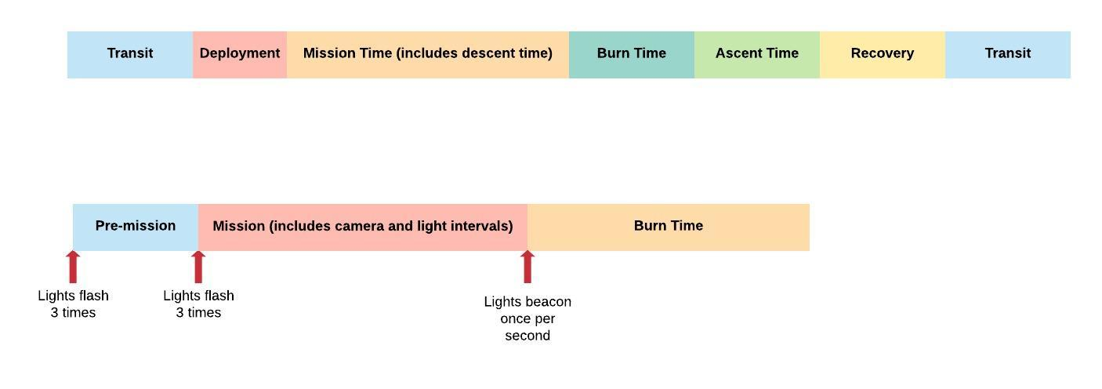

#### Do’s and Dont’s

##### DO

* Use proper bait - bait should be mashed
  + Recommended bait type is some type of **OILY**fish (i.e, sardines)
* The length of rope should allow the camera to hover around 2m above the seafloor
  + This is about 6ft if using pillowcase as anchor

##### DON’T

* Deploy a camera 24 hours before a transit time. If a primary release failure occurs, this is the minimum time for the secondary release to function.

## **Deployment log**

<https://docs.google.com/spreadsheets/d/1gEil1Y-yQwwCsy_o14RR_WSZDkbyJxycOvN8z-lKWp8/edit?usp=sharing>

Linked above is the template for the deployment log. Be sure to consistently track this information throughout the deployments. We ask that a deployment journal to also be noted to collect qualitative feedback on what worked best for your deployment, what factors were an issue, etc.

## **External attachments**

The Dropcam can be packed fairly small if required. The following should where to attach external assemblies if disassembled.

### **Flag**

Attach the flag in the following location using the included bolt.

*Flag itself will need to be threaded into this frame attachment. Be sure to zip-tie flag (4-way) at the base of where it threads.*

Attach the flag in this configuration. **NOTE** Tighten as far as possible without restricting movement.

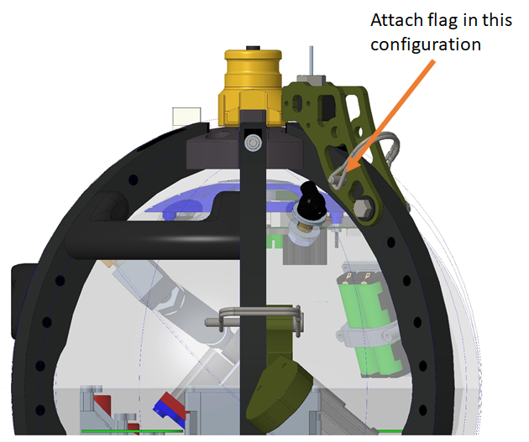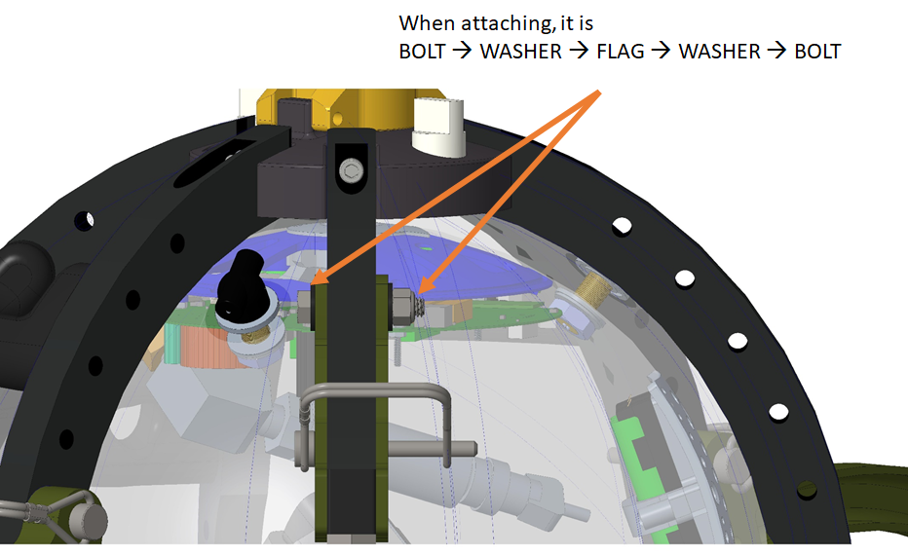

See below for pin placement for flag configurations.

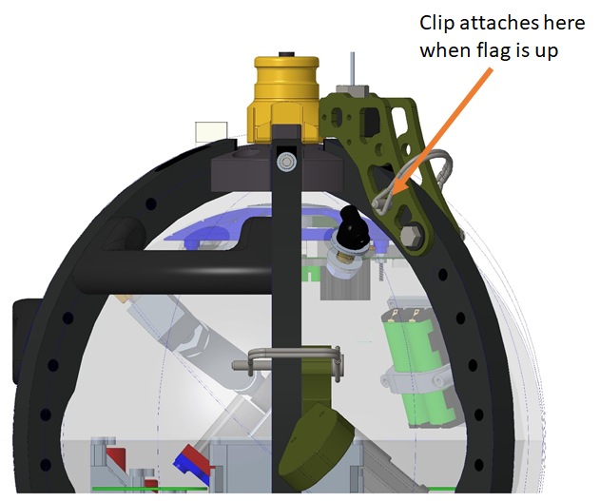 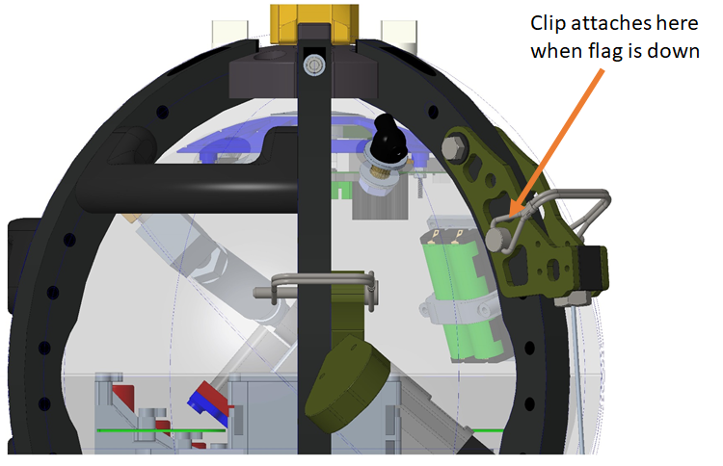

### Separating the sphere

1. Remove and loosen bolts on frame

### 

1. Remove two front ribs near camera on both top and bottom ‘hats’.
2. Loosen all remaining bolts slightly (they do not need to be removed all the way, just to loosen tension around the sphere)
3. Unplug lights from sphere.
4. Lay sphere gently on stand at an angle. See below.

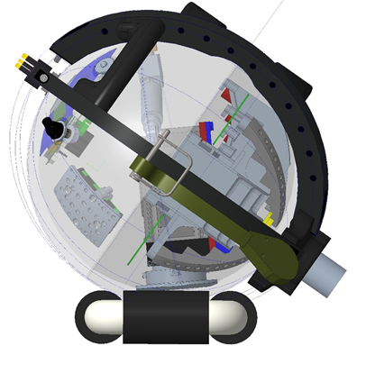

1. Undo vinyl tape and butyl rubber tape.
2. Release vacuum. The sphere halves should could apart easily. If not, hold down the vacuum release for longer.
3. Separate the two sphere halves and place on the correct stands.

### Sealing the sphere

1. Clean the interface thoroughly using only Kim wipes and rubbing alcohol [70%] (Ensure NO particulates are left on the surface. (User kit includes presaturated KimTech wipes)
2. Mate the two hemispheres and ensure there is no overlap in any area.
3. Completely dry the air inside the sphere by vacuuming the sphere to -4 psi then refilling with dry air THREE TIMES.
4. Vacuum sphere to -6 psi.
5. Replace vacuum cap. ENSURE O-RING IS PROPERLY INSTALLED.
   1. Be sure to moisten the o-ring with Molykote 55, if needed, prior to installation.
6. Place butyl rubber tape around interface, leaving a 3 cm overlap.
7. Place 3 wraps of vinyl sealing tape.
8. Monitor the vacuum to ensure that it is holding.
   1. This is something you’ll want to check on periodically throughout the expedition.
   2. Minimum is -3 PSI. If steadily neutralizing in pressure, please notify us ahead.
9. Replace frame and tighten all bolts, TOP and BOTTOM.
   1. Coat bolts lightly (refer to picture in cheat sheet) with NEVER-SEEZ grease.
      1. This only needs to be done once during initial set-up.

## **Set Up Procedures**

#### Locating parts:

Camera Magnet: OPPOSITE of camera

Beacon Magnet: ABOVE camera

Pressure Gauge: Opposite of vacuum port (top half of sphere)

Vacuum port: Cap with Nautilus logo (shell)

Temperature sensor: Small port near outside of sphere pressure gauge (to be rinsed with syringe after every deployment

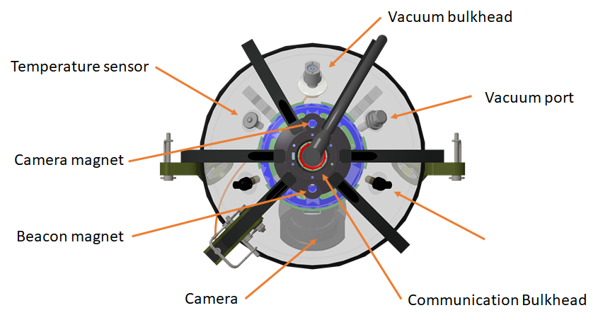

### Function Test

The following should be used to check the functionality of the Dropcam prior to any deployment.

NOTE: This test should also be run **prior to sealing the sphere** [i.e. upon arrival after travel to an expedition (when batteries have been re-connected), and after any open-sphere adjustments or tinkering, etc.].

1. Ensure Beacon Magnet and Camera Magnet are screwed in. This is to make sure the camera and electronics are off. The beacon magnet must be in while communicating with the Dropcam.
2. Attach programming cable to the camera.
3. Plug in USB to computer. The Dropcam will start its mission once the camera magnet is removed unless the USB is plugged in. It is recommended to turn up the volume on the computer so the USB connection sound can be heard when the Drop-cam turns on.
4. Remove camera magnet.
5. On desktop, double click TEST_MISSION.ttl
6. If no text shows on the Tera Term window, check the COM port using Setup → Serial port (see Troubleshooting section for pictorial instructions on which COM port to select)
7. Program should load. The last lines should read the mission parameters.
8. Once program has loaded, screw in camera magnet. Wait until “Shutting down…” shows up on screen. Also, the small green LED should turn off on the Dropcam.
9. Close Tera Term.
10. Replace Programming Cable with Release Cable and attach the Release Tester (buzzer).
11. Remove camera magnet to begin test.
12. During the test program the following should happen:
    1. The lights should flash 3 times indicating the start of the mission. There will be a 30 second pause, then the lights should flash 3 times again.
    2. Lights and camera should turn on for 30 seconds, then off for 30 seconds, twice. The camera shutter will open indicating that the camera is turned on.
    3. The lights should flash 3 times indicating the end of the mission.
    4. Release Tester should make a high pitched sound after mission end. Once the Release Tester begins to sound, simply unplug one of the Release Tester wires.
13. Screw in camera magnet to conclude the test.
14. Wait for green LED to turn off before proceeding.
15. If anything in step 12 does not occur, contact NG for further assistance.

### Check Beacon and Argos

*(Note: Be sure to position Argos tester as close to the top of the sphere. Tester goes off once every 1-5 minutes)*

1. Unplug the cap from the VHF receiver antenna port and attach the VHF antenna.
2. Turn on VHF receiver and ensure that it is set to the frequency for the Dropcam you are testing.
3. Turn on the Argos tester and set sensitivity to “High”. The Argos tester needs to be placed as close to the beacon as possible.
4. Remove beacon magnet.
5. Adjust gain and volume as necessary until you hear a “chirp” sound. It should be short and come in every second.
6. Listen for the “beep” from the Argos tester. It should come once every minute. Be patient: this may take a few minutes.
7. Screw in the beacon magnet to conclude the testing.
8. Remove the VHF antenna and replace the cap onto the VHF receiver.

### Check Camera Hard Drive

#### Automated Method for checking Cam HD

1. Ensure Beacon Magnet and Camera Magnet are screwed in. This is to make sure the camera and electronics are off. The beacon magnet must be in while communicating with the Dropcam.
2. Attach programming cable to the camera
3. Plug in USB to computer.
4. Remove camera magnet.
5. On desktop, double click DOD-CAM_USB.ttl
6. If no text shows on the Tera Term window, check the COM port using Setup → Serial port (see index for pictorial instructions).
7. Go to “This PC” (aka “My Computer”) and look for a drive called “USB Hard Drive”. This is the camera hard drive.
8. Confirm that video files from the function test were recorded onto the camera and are accessible (see “Check Camera Hard Drive” below).
   1. Confirm that files are from current test, and not from previous activity.
   2. Confirm that video is in focus.
   3. Confirm that file date/times are correctly set (to UTC); if not, properly set them in the camera’s settings.
9. Check to see if there is anything on the camera hard drive that needs to be stored. Otherwise, ensure the camera hard drive is empty.
   1. To clear the camera HD, delete the entire PRIVATE folder.
10. Once you’ve finished with the camera hard drive, screw in the camera magnet. Wait until “Shutting down…” shows up on screen. Also, the small green LED should turn off on the Dropcam.
11. Close Tera Term.
12. Wait for green LED to shut off before proceeding.

#### Manual Method for checking Cam HD

1. Ensure Beacon Magnet and Camera Magnet are screwed in. This is to make sure the camera and electronics are off.
2. Attach programming cable to the camera.
3. Plug in USB to computer.
4. Remove camera magnet to turn Dropcam on.
5. Check to make sure Dropcam is on.
6. Open Tera Term.
7. Wait for “Press any key for command prompt…”
8. Press “Enter” TWICE.
9. Press “v” then “Enter”.
10. Wait for “CAMERA ON”
11. Press “u” then “Enter”.
12. Go to “This PC” and look for “USB Drive”

### Programming Mission

1. Close any instance of Teraterm that is open.
2. Attach programming cable to the camera.
3. Plug in USB to computer.
4. Ensure Beacon Magnet and Camera Magnet are screwed in. This is to make sure the camera and electronics are off.
5. Remove camera magnet.
6. On desktop, double click the appropriate mission file.
   1. See Expedition Essentials on the desktop to pre-programmed missions
      1. There is a corresponding spreadsheet that outlines mission start/stop intervals of the pre-programmed missions.
7. If no text shows on the Tera Term window, check the COM port using Setup → Serial port (see here for pictorial instructions)
8. Program should load. The last lines should read the mission parameters.
9. Once program has loaded, replace camera magnet. Wait until “Shutting down…” shows up on screen. Also, the small green LED should turn off on the Dropcam.
10. Close Tera Term.
11. Grease release cable using Molykote 44. See Connector Greasing Instructions for further instructions.
12. Replace programming cable with release cable to prepare for deployment. Secure the release cable by using zip ties with the release cable holder.

### Inspecting seal and cabling for damage

Inspect the seal daily to ensure that is completely covering the sphere interface. Check cabling for any small nicks or exposed wire. If any defects are found, contact NGS.

### Checking Vacuum

The vacuum pressure on the Dropcam should be checked frequently, and should range between 4 - 6 psi. Make sure to log the vacuum pressure in the Dropcam log every day. This will allow you to see if there are changes in the vacuum pressure, indicating a potential leak. If there is any leak, make sure to contact NG HQ and report the problem.

The pressure inside the sphere may vary over time with changes in temperature. Pressure fluctuations are acceptable, however if there is a general reduction in the vacuum, that is the pressure dial moves closer to 0, there is a problem somewhere on the sphere.

*NOTE: In your deployment log you will be able to record sphere vaccuum for tracking purposes.*

### How to attach release cable securely to frame:

HACK (only applicable for new dropcam hat without proper fittings)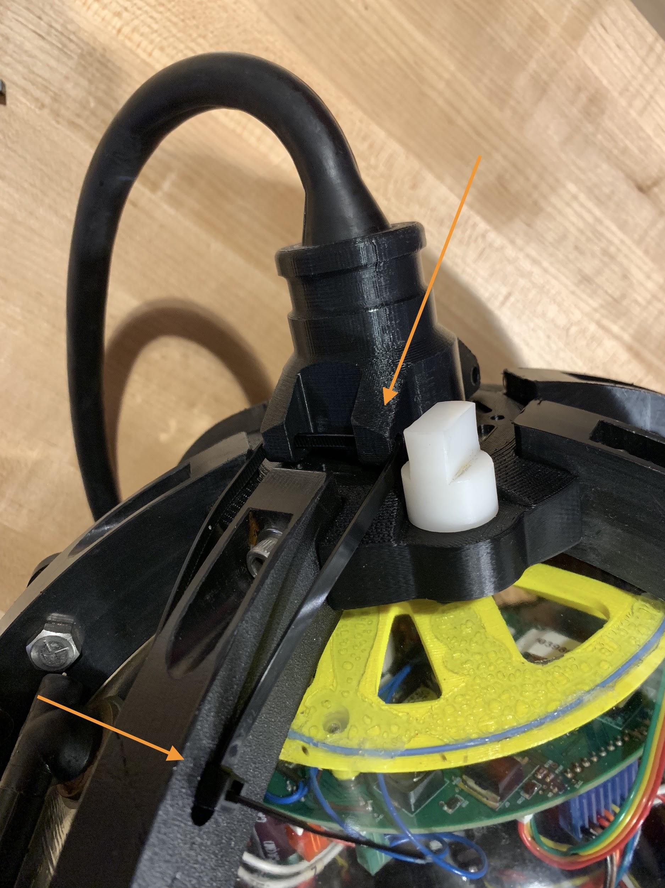

1. Make sure 3D printed part is threaded around release cable header (side with pins)
2. The 3D printed part will need to be positioned **diagonally** across the top of the dropcam.
3. Secure on **each side** to the frame.
   1. There will only be one way this will work because the frames will only have one hole open closest to the top of the dropcam.

### Attaching Burnwire and GTR

**IT IS EXTREMELY IMPORTANT TO ATTACH THE BURNWIRE AND GTR CORRECTLY.**

The release assembly is critical and care should be taken to ensure that everything is attached correctly.

1. Remove burnwire bolt at the bottom of the bait stem.
2. Run burnwire cable through cable guide opposite of bait cannister.
3. Re-insert bolt through burnwire. INSERT FIGURE
   1. Be sure that the cabling leaving the loop is managed neatly and positions itself in the direction of where it needs to feed up
4. Ensure there is no corrosion on the anode bolt. Clean if necessary using fresh water and a toothbrush or wire brush.
5. Attach burnwire cable and anode cable to the release cable.
6. Zip tie and tuck any excess cable length neatly into the cable guide.
7. Secure connectors with vinyl tape (electrical tape).
8. Attach GTR to burnwire. NEVER ATTACH GTR TO ANODE BOLT.
9. Tug on the release loops to make sure everything is properly secured and nothing comes undone.

Helpful tip: Burnwire attaches to Dropcam, GTR attaches to Burnwire.

#### RESOURCE (if anchor is not able to be left behind)

### Prepare Anchor and Bait

The anchor weight should be approximately 10 kg. Use a spring scale to easily weigh the anchor. Use natural rope and cotton sandbags or pillowcases if possible. The anchor should be attached with a 2m line. See the “Knots” section for illustrations.

Bait is usually 1 kg of oily fish. Make sure to mash bait appropriately. To insert bait, simply remove the top cap, insert bait, and replace lid.

## **Deployment**

### 

### Using the GPS

The GPS may require a few minutes to achieve a location once turned on. Be patient and wait until the GPS has an accurate fix before using.

To mark a location:

1. From any screen, press the ‘Mark’ button
2. If desired, use the arrow keys to scroll up to the NAME (top field, next to the blue flag) and enter a unique name
3. Once complete, scroll down and highlight the DONE box and press the ‘Enter’ key

To retrieve time and coordinates:

1. From any screen, press the ‘Page’ key until MAP is highlighted then press ‘Enter’
2. Use the arrow keys to hover over the desired waypoint. Use the ‘In’ and ‘Out’ buttons as neccessary to find the waypoint. Once highlighted, the name of the waypoint should appear in the upper left hand corner.
3. Once the arrow is over the waypoint press ‘Enter’ to see the time the waypoint was logged and the coordinates

To navigate to a waypoint:

1. From any screen, press the ‘Find’ button
2. Select your waypoint and press enter

## **Recovery**

### Using the VHF receiver and Yagi antenna

1. Turn on the VHF receiver and ensure it is set to the correct frequency.
2. Attach the Yagi antenna.
3. Turn the gain up until you just begin to hear static, then turn the gain down slightly.
4. Rotate slowly in a circle, listening for changes in signal volume.
5. If no change in volume can be detected, turn gain down a little and recheck for change in volume by slowly turning in a circle.
6. Choose a heading by determining the rough direction that the volume is loudest, and confirmed by where volume is softest (the two locations should be in opposite directions).

## **Completing the Droplog**

Filling in the Droplog is straightforward.

NOTE: Your DOEX#### will be assigned to you ahead of the expedition.

The DOD### is referenced on the Dropcam’s label.

There will be tooltips for each category in case you forgot what should go in each column. Also refer to ‘Data Terms’ sheet for a full list of all column types.

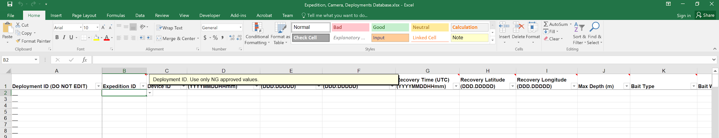

There will be a dropdown list for a few of the columns. Make sure that all values are in the format listed in the column header.

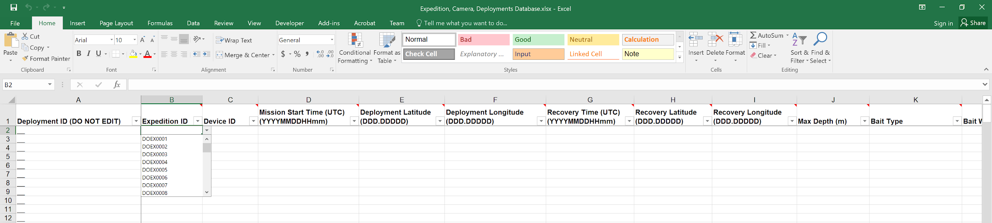

Note that the Deployment ID is automatically generated from the other columns.

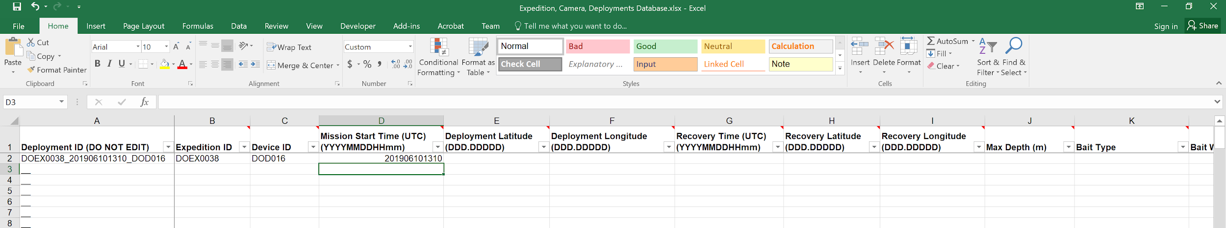

## **Deployment ID generator**

<https://docs.google.com/spreadsheets/d/1HEkEdsyvlgOIksWBHMQml4I1MjtRUGXjWMI8c6C7jA0/edit?usp=sharing>

## **Data Download**

### LABVIEW DATA DOWNLOADER (NEW PACKAGED SOFTWARE)

1. Launch Labview “Data Downloader” project.
2. Connect the USB cable from the Dropcam Comms cable to the computer.
3. Select COM Port (make sure the camera magnet is out, to be able to connect to the device)
   1. This may take a moment, you’ll know it is ready when the green status light under connected is illuminated
4. Select what you would like to download.
5. If “Download all data” is selected follow the prompts for:
   1. Deployment ID
   2. Choose the folder you’d like the data saved to
      1. Be sure to double click into the main folder you want the data to live
   3. Select Current Folder
6. Allow download project to go through task of downloading
   1. Sensor Data
   2. Mission Data
   3. Video Data
7. Prompt will appear to enter Latitude of deployment when the sensor data is downloading
8. Project will run the commands to access the camera video data (note: additional windows will pop up, but no action is to be taken by user)
9. Project will prompt when download is complete.

**Reminders**:

Make sure the beacon magnet is NOT removed. If removed, this will interrupt the data download process.

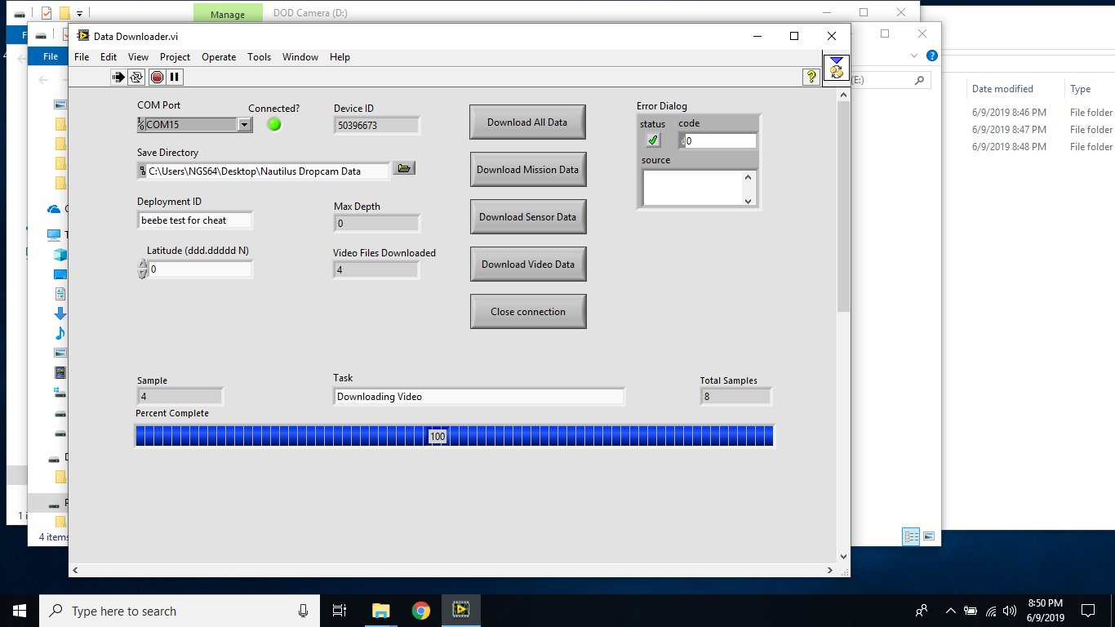

When download is complete, the project window will show the summary of the mission

-Deployment ID

-Latitude

-Max Depth

-Number of video files

-Number of samples

-Location where data was saved to

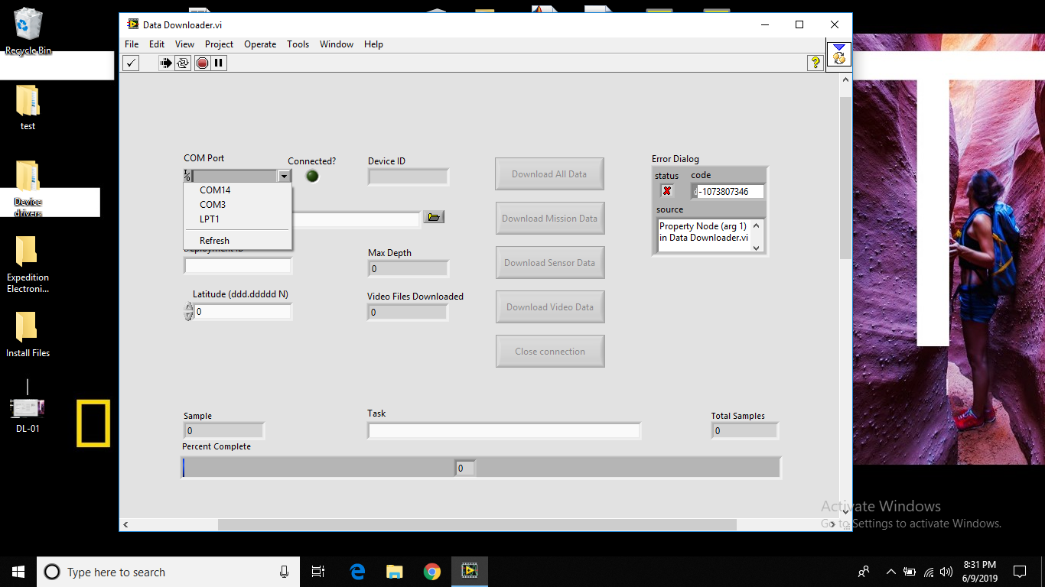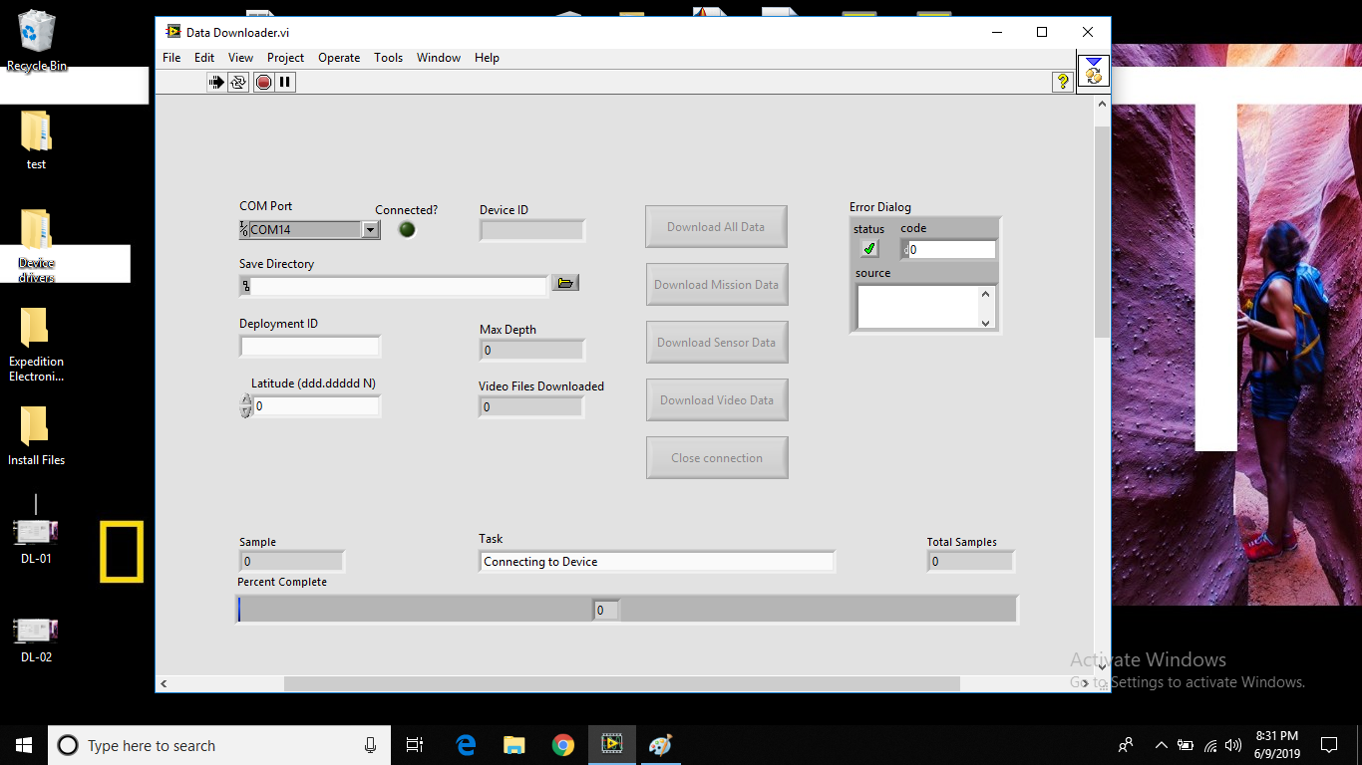

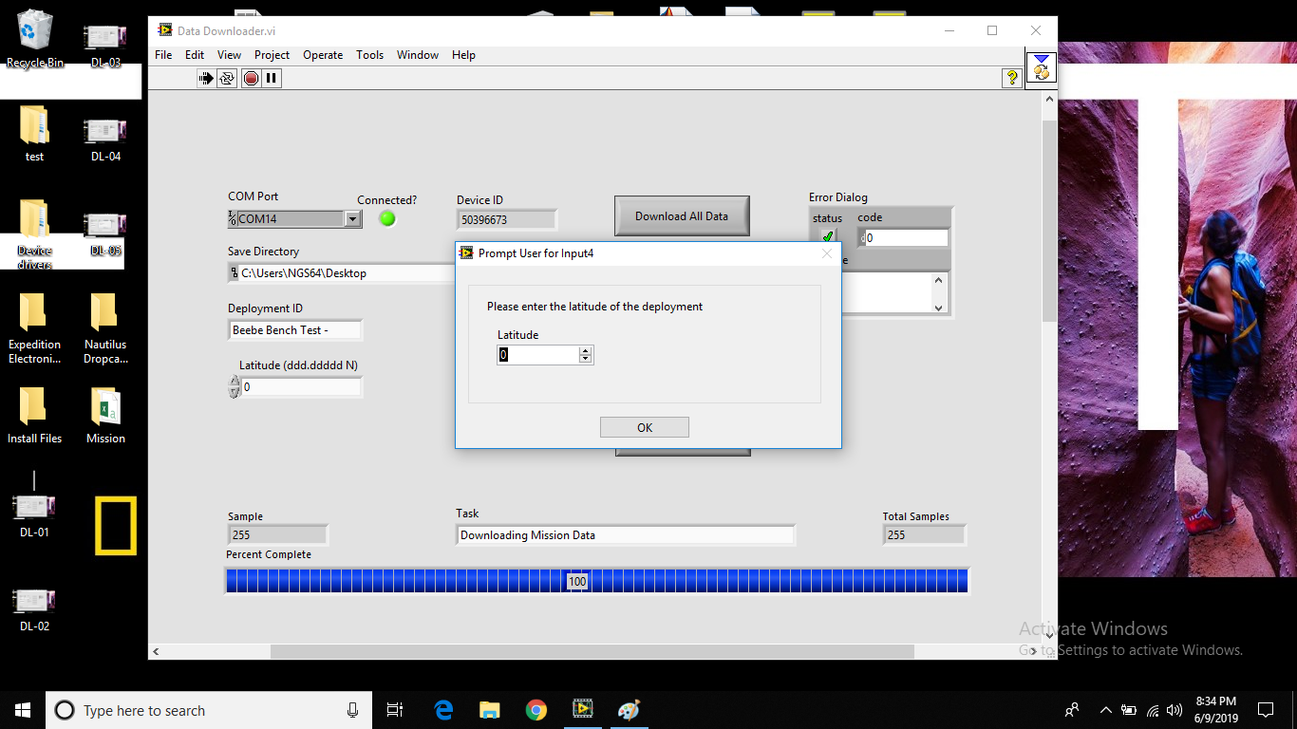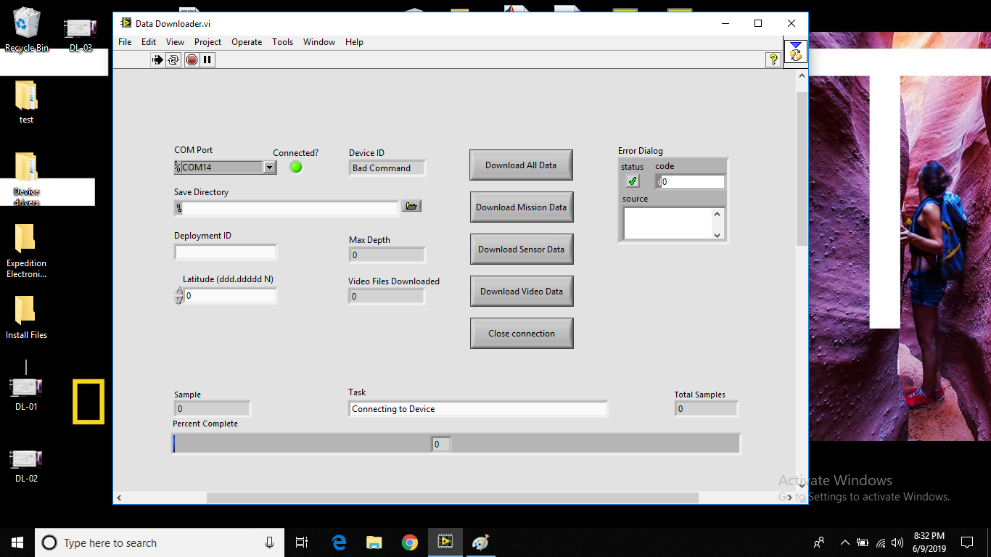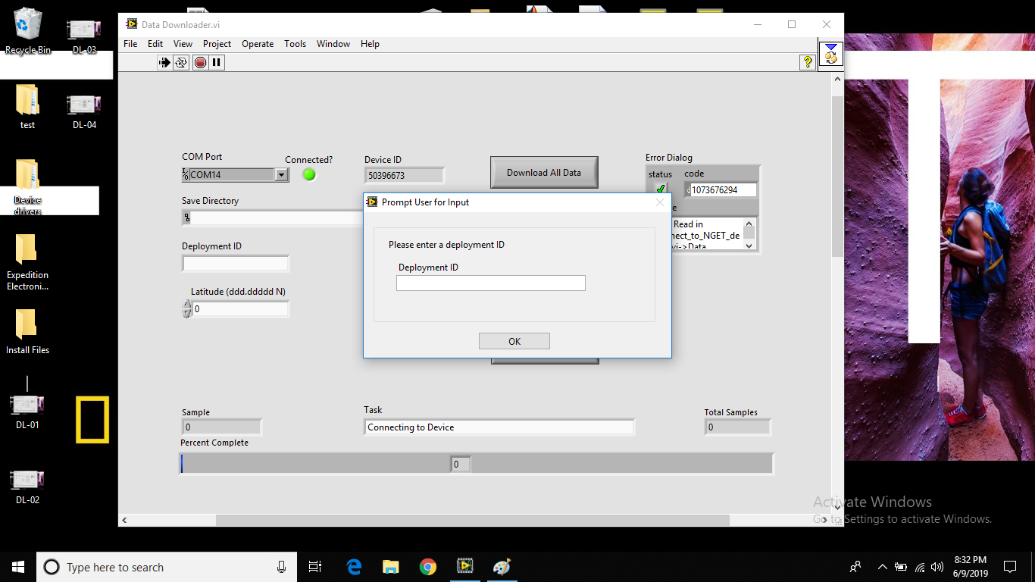

Downloading Video Data (using TERATERM)

*Automatic Method for downloading video data*

1. Ensure Beacon Magnet and Camera Magnet are screwed in. This is to make sure the camera and electronics are off. The beacon magnet must be in while communicating with the Dropcam.
2. Attach programming cable to the camera
3. Plug in USB to computer.
4. Remove camera magnet.
5. On desktop, double click DOD-CAM_USB.ttl
6. If no text shows on the Tera Term window, check the COM port using Setup → Serial port (see here for pictorial instructions).
7. Go to “This PC” (aka “My Computer”) and look for a drive called “USB Hard Drive”. This is the camera hard drive.
8. Transfer contents to data storage.

*Manual Method for downloading video data*

1. Ensure Beacon Magnet and Camera Magnet are screwed in. This is to make sure the camera and electronics are off.
2. Attach programming cable to the camera.
3. Plug in USB to computer.
4. Remove camera magnet to turn Dropcam on.
5. Check to make sure Dropcam is on.
6. Open Tera Term.
7. Wait for “Press any key for command prompt…”
8. Press “Enter” TWICE.
9. Press “v” then “Enter”.
10. Wait for “CAMERA ON”
11. Press “u” then “Enter”.
12. Go to “This PC” and look for “USB Drive”
13. Transfer contents to data storage.

### Downloading Pressure and Temperature Data

*(Note: This can be performed at the same time the video data is being downloaded. Be sure to close TeraTerm before launching Labview. The programs cannot be running simultaneously.)*

1. Double click on the “Data Downloader - Shortcut” icon on the Desktop.
2. Make sure Tera Term is not connected to the Dropcam. If so, simply close the Tera Term window.
3. Press “Launch Labview”.
4. If prompted to extend software licenses, select “No”.
5. Press the “Run” button in the upper left hand corner.
6. Select the correct COM port from the drop down menu.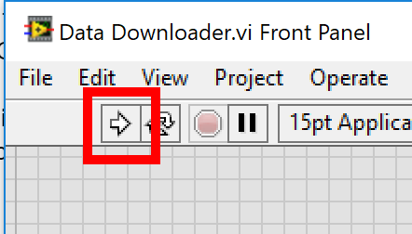
7. Camera is connected if the light turns green.
8. Press “Connect to camera”.
9. Enter the name of the deployment.

### Plotting Pressure and Temperature Data

1. Double click the “plot_dropcam_data_UI” shortcut on the desktop.
2. Wait for Matlab to load. This may take a minute.
3. Once Matlab has loaded, select the “Run” button on the top middle of the window.

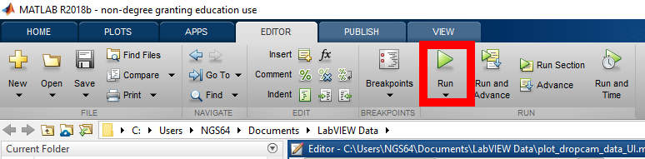

1. Select the file you would like to view. Press ok.
2. Select the latitude of the deployment. Press ok.

## Dropcam Data Folder/File Structure

DOEX###/

## How to charge Dropcam:

1. Connect Blue connector of charger to Blue connector of dropcam comm cable
   1. Make sure that the coordinating charge ends are the same.
2. Observe indicator light on charger cable block (green - fully charged, red - charging)  
   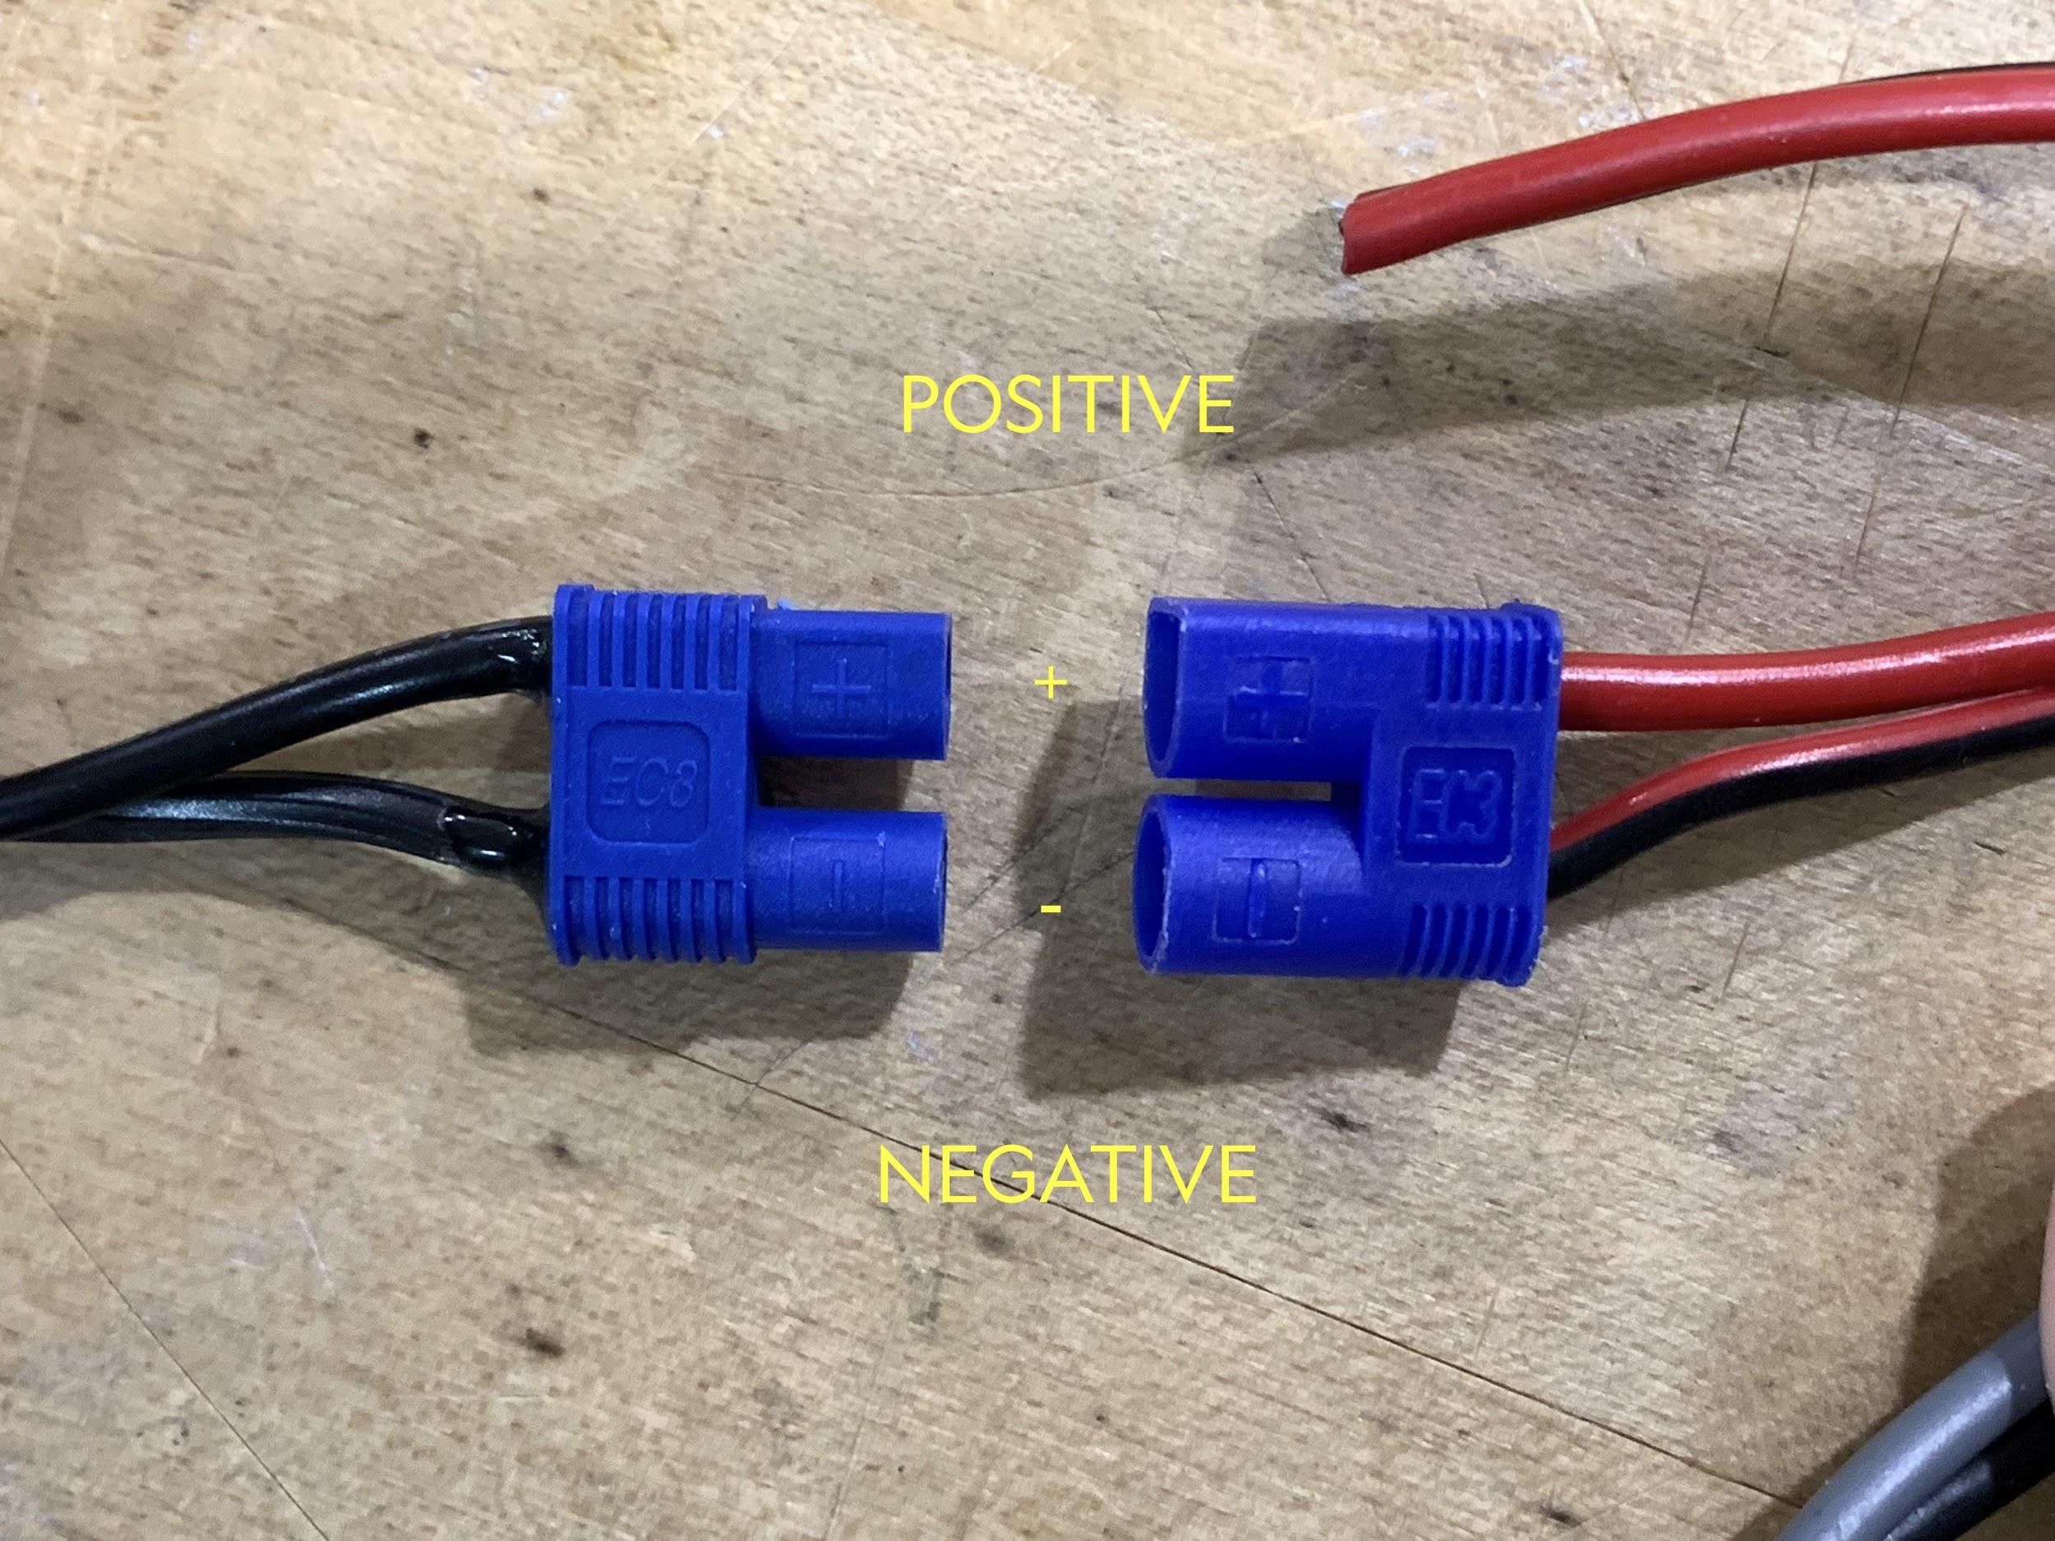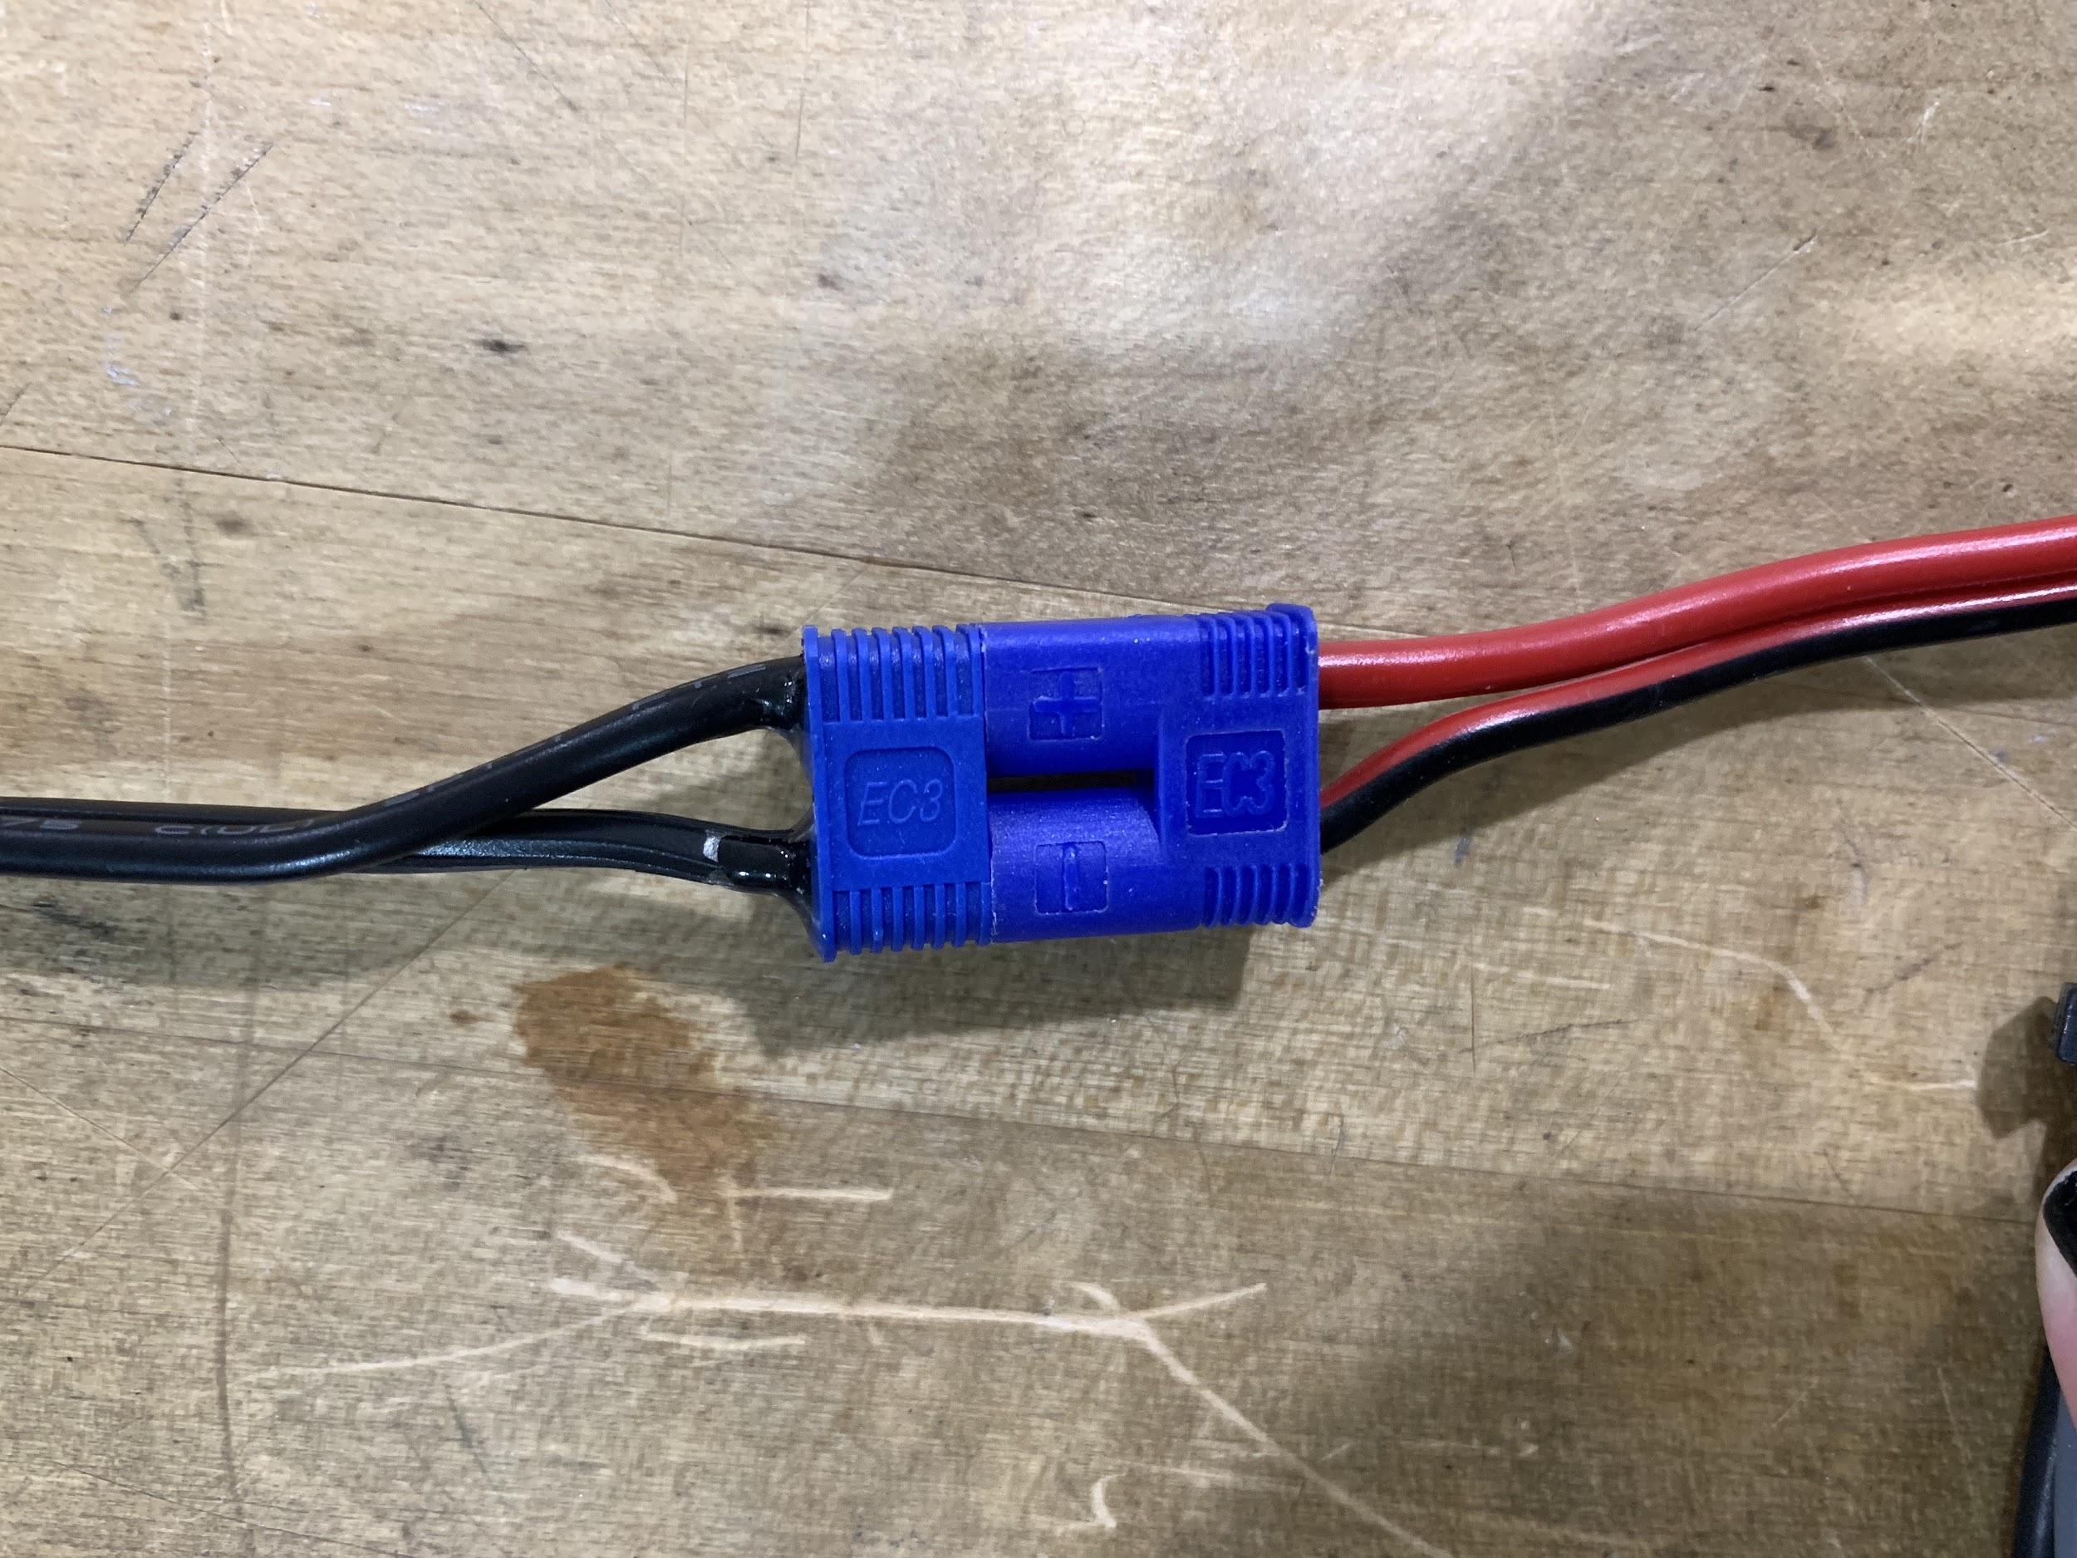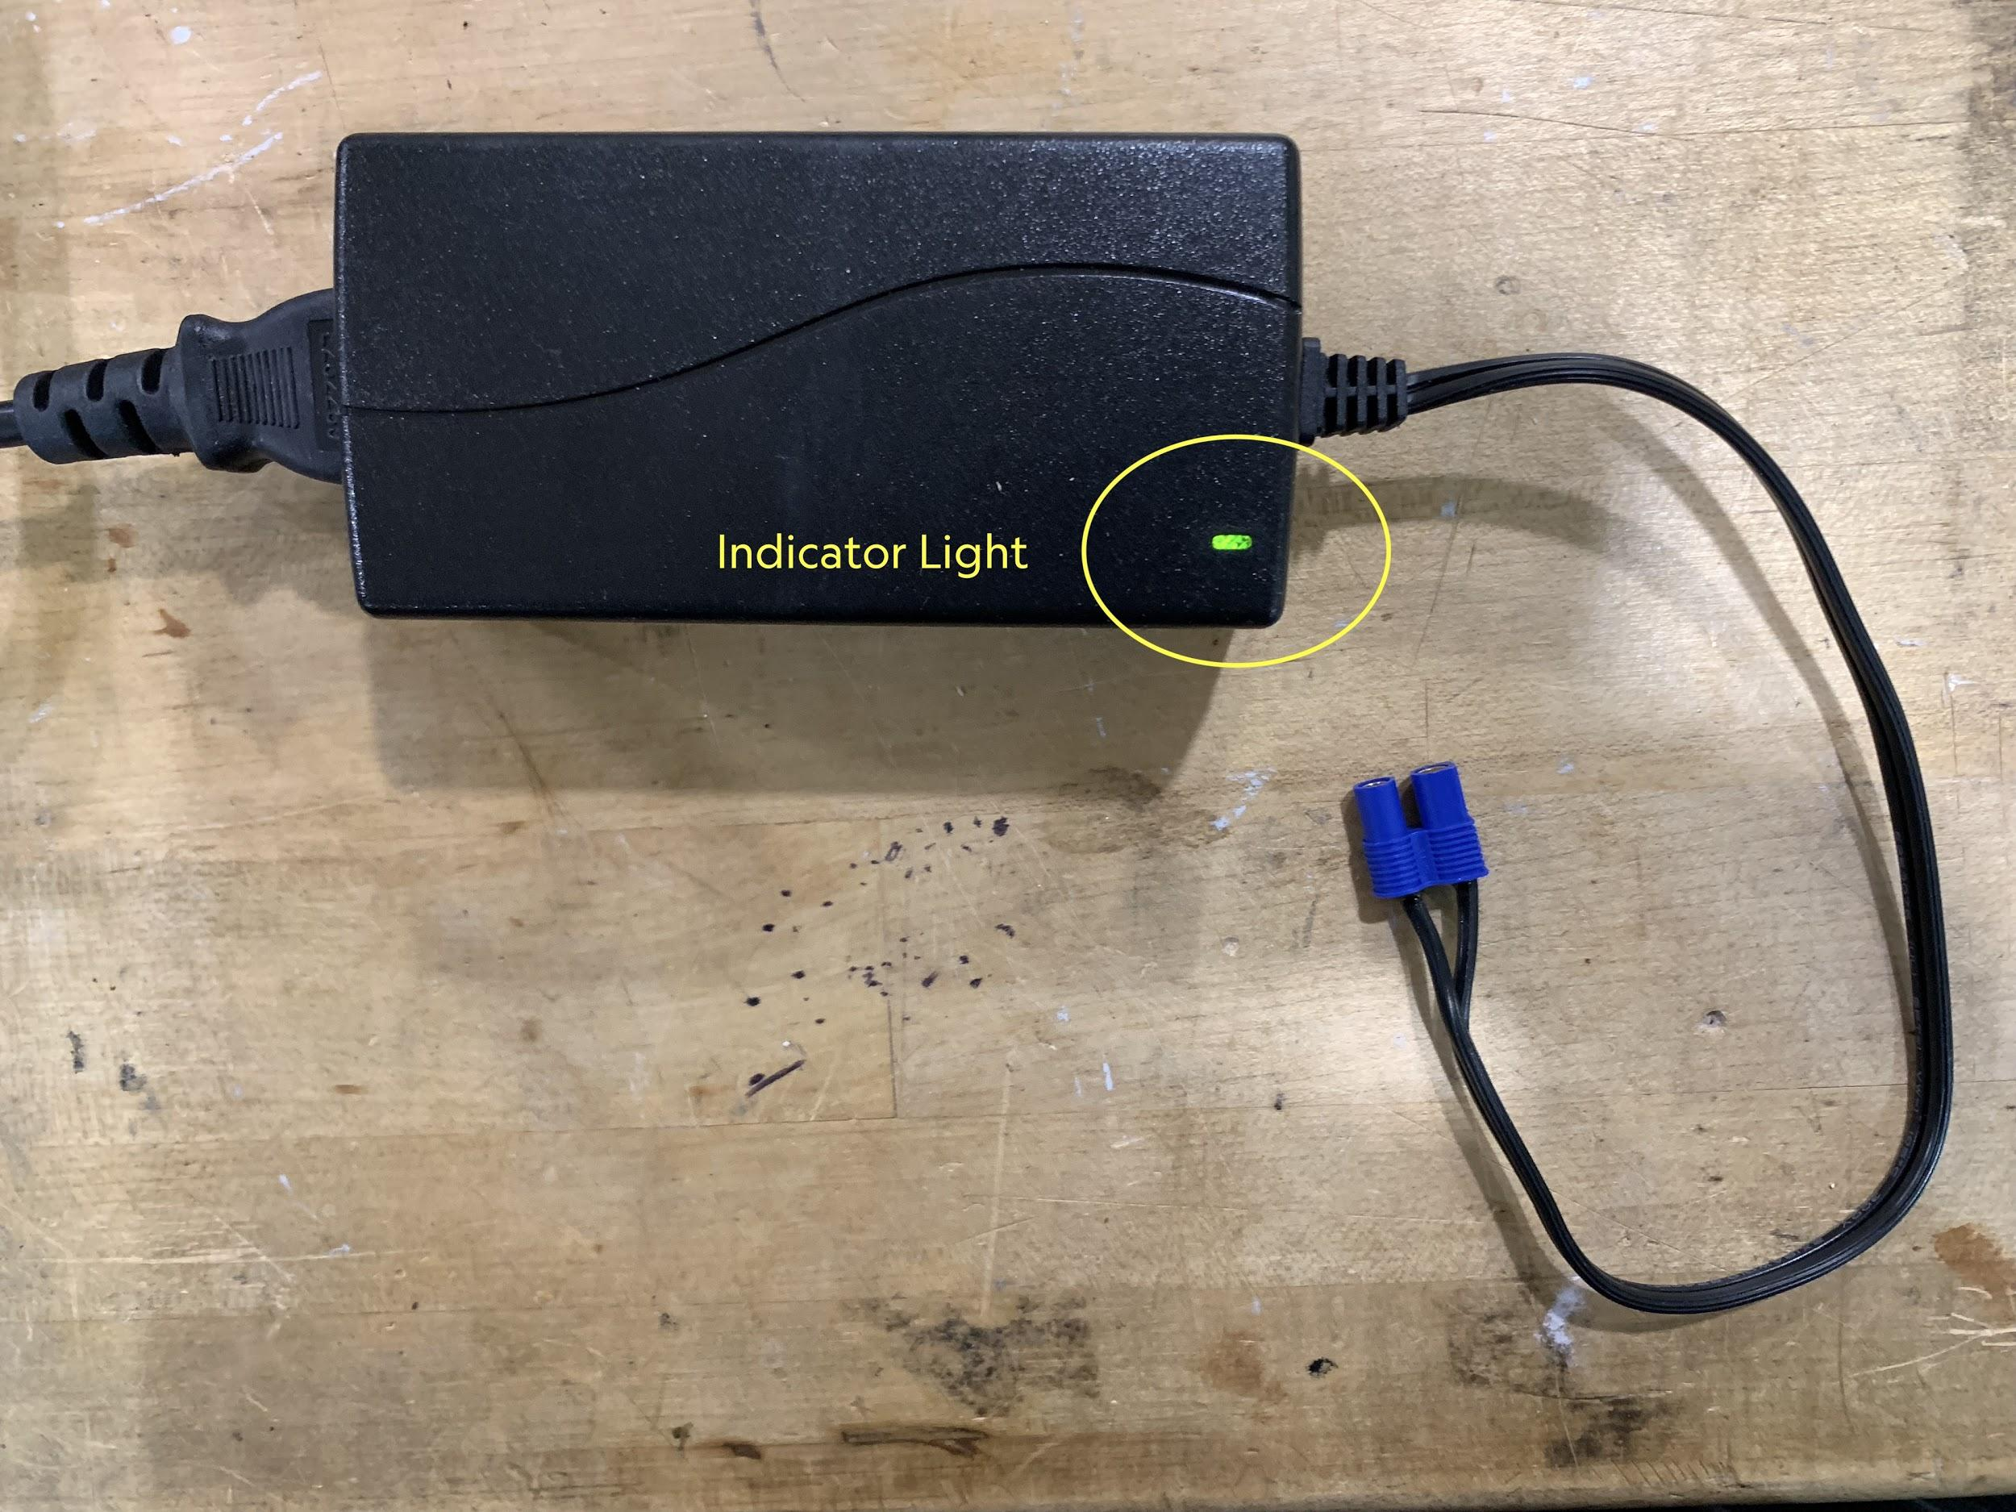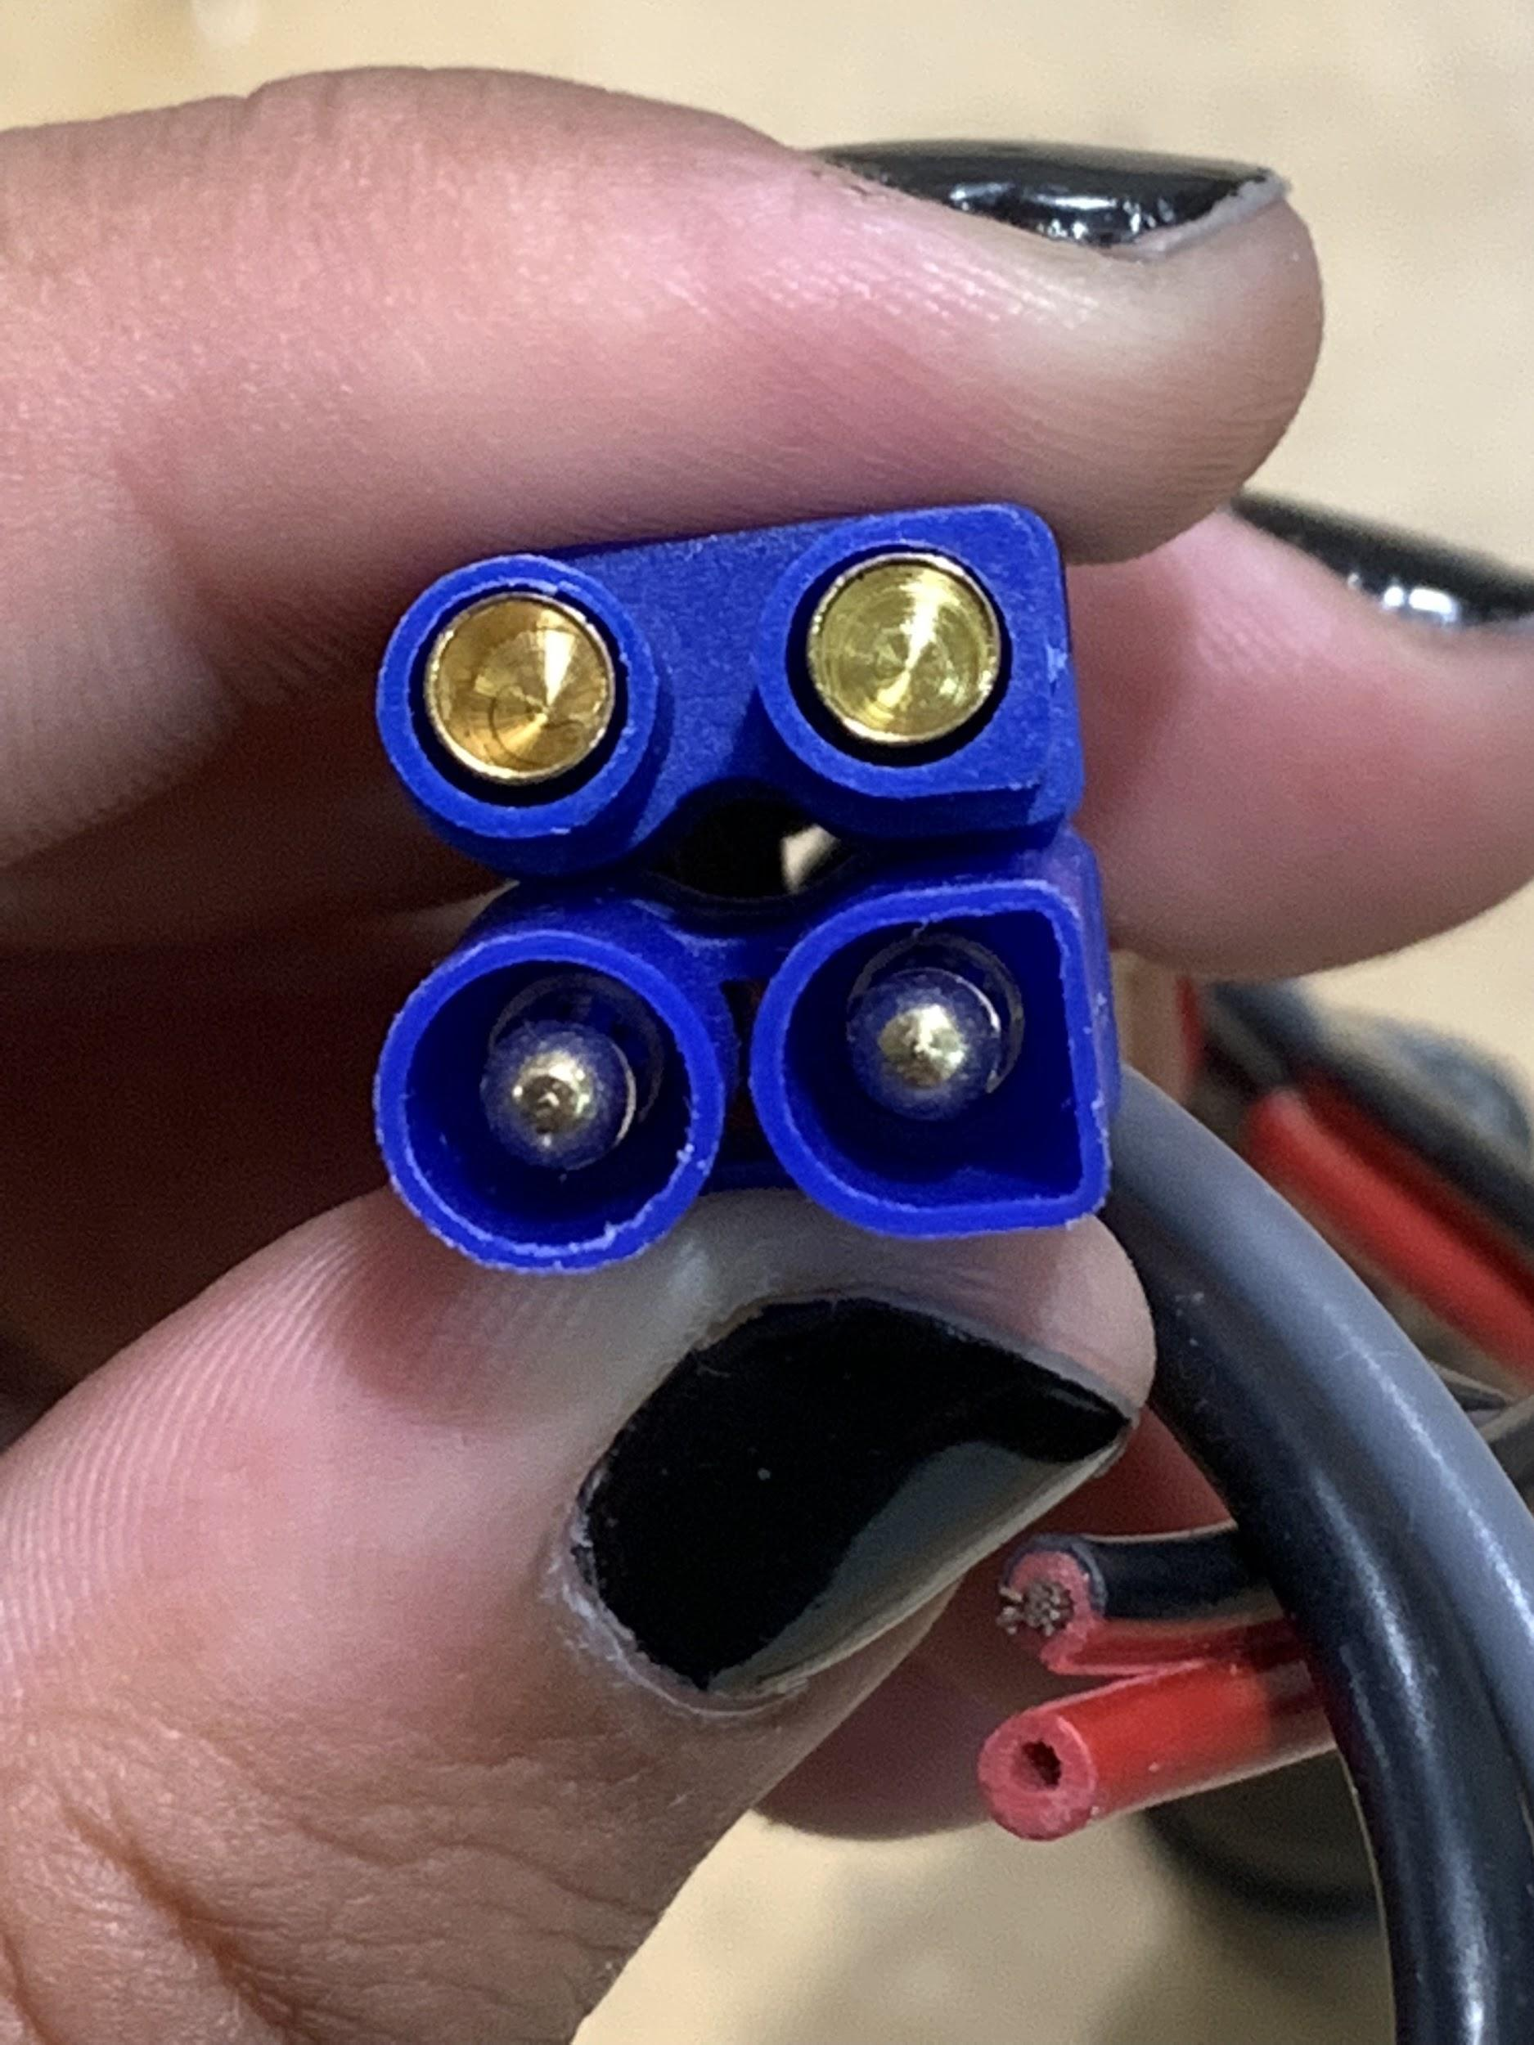

## 

## **Dropcam Illustrations**

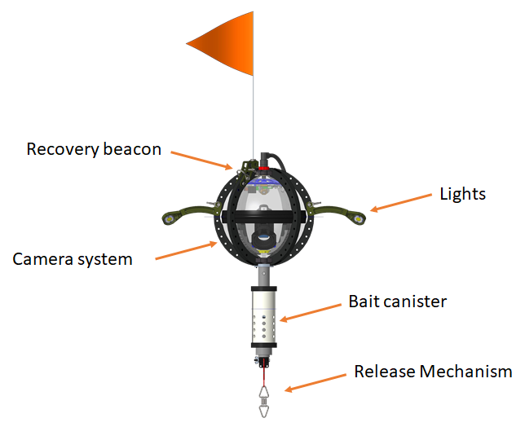

## Cables

|  |  |
| --- | --- |
|  |  |
| Comms/charge cable | Burnwire |
|  |  |
| Release cable | Release anode |
|  |  |
| Release tester | Dropcam charger |

## Troubleshooting

### **Problem:** Teraterm is showing nonsense characters.

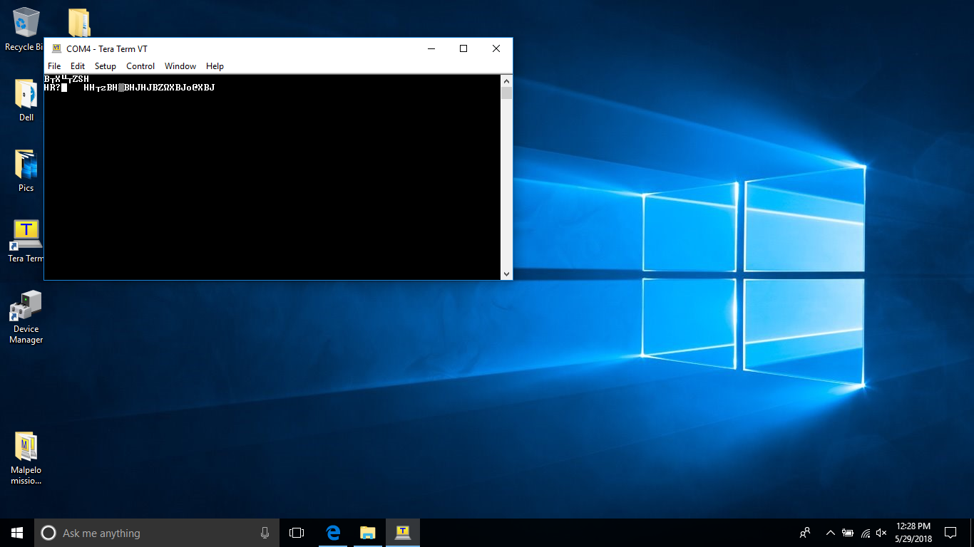

**Solution:** Make sure the BAUD RATE is set to 57600 under Setup → Serial Port

### **Problem:** When I open Teraterm, I don’t see any response from the Dropcam, even though the magnet is out and the USB cable is plugged in.

**Solution:** Check the COM port of the Dropcam.

### **Problem:** Error occurs when opening Tera Term “Cannot open COM. Not found.”

**Solution:** Close Tera Term. Check to make sure the Dropcam is on (camera magnet removed) and that the USB cable is firmly inserted.

If the problem persists, check the COM port.

Reopen Tera Term.

### **Problem:** Tera Term shows [disconnected]

**Solution:** First, check to make sure the Dropcam is on (camera magnet removed) and that the USB cable is firmly inserted.

First, check to make sure there are no other programs connected to the Dropcam (e.g. another Tera Term window, or the Data Downloader).

Otherwise, check the COM port.

### **Problem:** Tera Term showing “Bad Command”.

**Solution:** Don’t worry this is normal. Carry on with whatever you were doing.

### **Problem**: Camera continually disconnects from USB at irregular intervals.

**Solution**: Most likely this is due to the beacon being on while trying to connect to the Drop-cam USB. Try turning off the beacon by fully screwing the magnet switch in.

### **Problem:** Camera stuck in start-up menu, preventing video recording from occurring.

**Solution:** Connect to the camera via Tera Term window, press “v” to toggle camera on. Manually go through camera settings (on camera interface) to set everything as detailed in [PDF documentation of camera settings].

## Procedures

### Connector Greasing Instructions

From: https://www.macartney.com/media/2609/subconn-handling-instructions.pdf

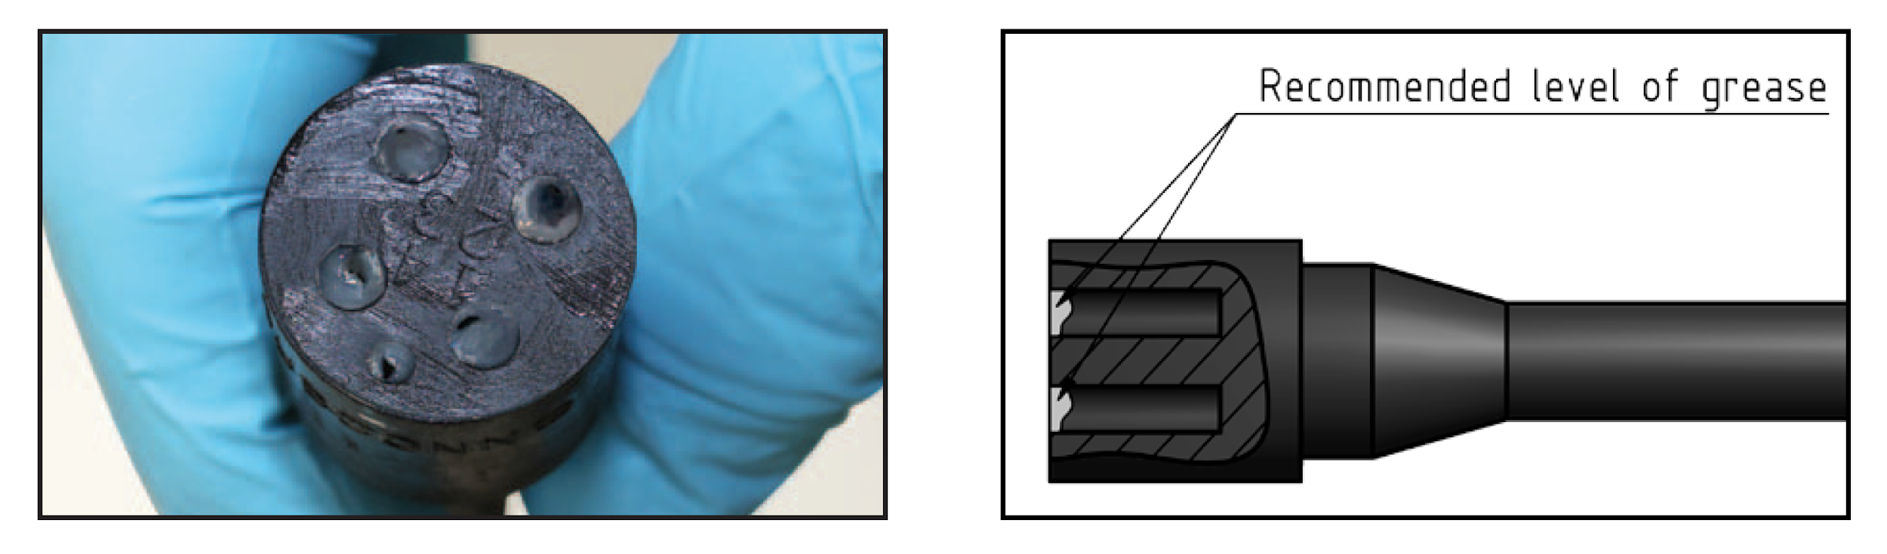

* Connectors must be greased with Molykote 44 Medium before every mating.
* A layer of grease corresponding to minimum 1/10 of socket depth should be applied to the female connector.
* The inner edge of all sockets should be completely covered, and a thin transparent layer of grease left visible on the face of the connector.
* After greasing, fully mate the male and female connector in order to secure optimal distribution of grease on pins and in sockets.
* To confirm that grease has been sufficiently applied, de-mate and check for grease on every male pin. Then re-mate the connector.

### Checking the COM Port and Saving the Settings

|  |  |
| --- | --- |
| 1. Open device manager. |  |
| 2. In Device Manager, select Ports. |  |
| 3. Check COM port number for “USB Serial Port” (in this case it is COM4) |  |
| 4. Open Tera Term and go to Setup → Serial port... |  |
| 5. Change the Port: to the correct number (COM4 in this instance). Press OK. |  |
| 6. To save the setup go to Setup → Save Setup… |  |
| 7. Then click “Save” once this screen shows |  |

### Configuring the Serial port settings

|  |  |
| --- | --- |
| 1. Open Tera Term and go to Setup → Serial port... |  |
| 2. Settings should be as follows:  **Port**: (based on device)  **Baud rate**: 57600  **Data**: 8 bit  **Parity**: none  **Stop**: 1 bit  **Flow control**: none  **Transmit delay**:  0 msec/char  0 msec/line  Press OK. |  |
| 3. To save the setup go to Setup → Save Setup… |  |
| 4. Then click “Save” once this screen shows |  |

## CHECKLISTS

### **PRE & POST DEPLOYMENT CHECKLIST**

Pre-Deployment

|  |  |
| --- | --- |
| Test Mission |  |
|  | Connect laptop to Dropcam with programming cable |
|  | Remove camera magnet |
|  | Load test program ('DOD Mini Test Mission.ttl') |
|  | Replace camera magnet |
|  | Remove programming cable |
|  | Put silicone mitts on lights |
|  | Attach release cable to dropcam |
|  | Attach buzzer to release cable connectors |
|  | Remove camera magnet to run test mission |
|  | Mission start (3 flashes) |
|  | Camera Ok? (shutter opens) |
|  | Lights Ok? (light on 10-15 sec) |
|  | Release Ok? (buzz) |
|  | Unplug release buzzer |
|  | Unplug releasecable |
|  | Replace camera magnet to end mission |
|  |  |
|  | Turn on argos tester to high |
|  | Place Argo tester next to top of Dropcam |
|  | Turn on VHF radio |
|  | Remove beacon magnet to test beacon |
|  | Set VHF on correct frequency |
|  | VHF beacon chirping? |
|  | Argos beep? (1-5 minutes) |
|  | Replace beacon magnet |
|  | Put away test equipment (mitts, buzzer, Argos tester, and other equipment) |
|  |  |
| Load Mission Program |  |
|  | Select Mission. (Create new mission if needed) |
|  | Log Mission Program name and duration on Deployment checklist |
|  | Connect laptop to Dropcam with programming cable |
|  | Remove camera magnet |
|  | Load selected mission program |
|  | Replace camera magnet |
|  | Remove programming cable |
|  | Prepare for deployment |
|  |  |
| Equipment set up |  |
|  | Attach stem |
|  | Remove burn bolt |
|  | Attach burnwire |
|  | Secure burn bolt |
|  | Attach GTR to bolt |
|  | Feed additional burnwire cable into pipe (cable management with zip ties) |
|  | Electrical tape around all connectors |
|  | Grease release cable |
|  | Insert release cable |
|  | Fasten release cable holder to top hat (zip ties) |
|  | Inspect all seals and cabling |
|  | Check vaccum (-4 to -6 psi) |
|  | Clean glass in front of camera |
|  | Prepare anchor to connect to GTR |
|  | Prepare bait |
|  | Attach flag |

Post Deployment

|  |  |
| --- | --- |
| Equipment Breakdown |  |
|  | Secure beacon magnet |
|  | Clearn bait can (but not too well) |
|  | Remoce used burnwire (Do not toss out!) |
|  | Remove used GTR (Do not toss out, keep in seperate container) |
|  | Fold/ Secure lights down |
|  | Fold/ Secure flag down |
|  | Fresh water rinse for all salty gear |
|  | Rinse pressure port with fresh water (use syringe) |
|  | Remove corrosion from release anode and release bolt (wire brush) |
|  | Stow all gear |
|  |  |
| Data Download |  |
|  | Enter dive information in Exp, Cam, Deploy Database spreadsheet |
|  | Save . changes |
|  | Create new folder named with Deployment ID in "LEX Dropcam Data" folder (on laptop) |
|  | Connect laptop to Dropcam using Comms cable |
|  | Charge dropcam (this can be done while downloading data) |
|  | Remove camera magnet |
|  | Open Data Downloader application |
|  | Choose correct COM port |
|  | Save Directory (choose the one you just created) |
|  | Select "Current Folder" |
|  | Click "Download all data" |
|  | Enter Deployment ID (generated by Exp, Cam, Deploy Database Spreadsheet) |
|  | Enter Depoyment Latitude |
|  | If there is an error, click OK |
|  | Downloading commences |
|  | Sanity check - total samples should be same as total mission time in seconds |
|  | When asked to delete data from camera, ignore (do not click yes or no) |
|  | Copy the new Deployment data folder to the external hard drive 1 |
|  | Copy the newest Deployment database spreadsheet onto the external hard drive 1 |
|  | Save photos of deployment checklists to external hard drive 1 |
|  | Copy all data from external drive 1 to the external drive 2 |
|  | Find data delete window, and click Yes |
|  | Charge Laptop |
|  | Charge GPS batteries, if needed |
|  | Charge iPad |

**DEPLOYMENT & RECOVERY CHECKLIST**

Pre-Deployment

|  |  |
| --- | --- |
| Date |  |
| Vessel |  |
| Cruise Number |  |
| Dropcam ID |  |
| Deployment Team |  |
| Dive Site Name |  |
|  |  |
| High Tide Time |  |
| Low Tide Time |  |
| Expected Conditions |  |
|  |  |
| Mission Program Name |  |
| Mission Duration |  |
| Estimated Depth (m) |  |
| Estimated time to surface (min) |  |
|  |  |
| Anchor Weight |  |
| Vacuum reading |  |
| VHF Frequency |  |
| Bait Type |  |

Deployment

|  |  |
| --- | --- |
| Mission Start Time |  |
| In Water Time |  |
| Latitude |  |
| Longitude |  |
| Depth |  |

Recovery

|  |  |
| --- | --- |
| Date |  |
| Recovery Team |  |
| Time on Deck |  |
| Time Cam Mag secured |  |
|  |  |
| Latitude |  |
| Longitude |  |
| Recorded depth |  |

Deployment Gear List

|  |  |  |  |
| --- | --- | --- | --- |
|  | Checklist |  | GPR |
|  | Fine-point Sharpie |  | ayeSailor |
|  | Dropcam |  | Tool case (snips, zipties, tape, etc) |
|  | Anchor |  | Depth sounder |
|  | Bait |  | Sat phone |
|  | Yagi antenna |  | Binoculars |
|  | VHF Radio |  | Buoy & Line (if applicable) |
|  | VHF/BNC Cable |  | Waterproof bag |

**BEFORE DEPARTING SHIP, REMOVE BEACON MAGNET**

Deployment Check List

|  |  |
| --- | --- |
|  | Check release assembly (Dropcam -> Burnwire -> GTR -> Anchor) |
|  | Attach bait |
|  | Raise & secure light arms |
|  | Raise & secure flag |
|  | Flip and secure camera cover |
|  | Remove camera magnet (log time!) |
|  | Deploy (log time) |
|  | GPS position (log on checklist & in GPS) |

Recovery Gear List

|  |  |  |  |
| --- | --- | --- | --- |
|  | Checklist |  | GPS |
|  | Fine-point Sharpie |  | ayeSailor |
|  | Yagi Antenna |  | Tool case (snips, zipties, tape, etc) |
|  | VHF Radio |  | Depth Sounder |
|  | VHF/BNC cable |  | Sat phone |
|  | Binoculars |  | Waterproof bag |
|  | Boat hook |  |  |

Recovery Check List

|  |  |
| --- | --- |
|  | Arrive on site prior to estimated time to surface |
|  | Turn on VHF/Yagi System |
|  | Find Dropcam |
|  | Recovery Dropcam (log time) |
|  | Secure Camera Magnet (log time) |
|  | Log recovery location (GPS and checklist) |
|  | Log recovery time |
|  | Take photo of front of this Checklist |

## 

|  |  |  |  |  |  |  |  |
| --- | --- | --- | --- | --- | --- | --- | --- |
| *Date* | 20200301 | 20200301 |  |  |  |  |  |
| *DOD* | 013 | 009 |  |  |  |  |  |
| **PRE-DEPLOYMENT** |  |  |  |  |  |  |  |
| *Function test* |  |  |  |  |  |  |  |
| Lights | x |  |  |  |  |  |  |
| Camera | x |  |  |  |  |  |  |
| Release | x |  |  |  |  |  |  |
| Beacon | x |  |  |  |  |  |  |
| Mission loaded | x |  |  |  |  |  |  |
| Release cable secured | x |  |  |  |  |  |  |
| Burnwire connected | x |  |  |  |  |  |  |
| Cables taped | x |  |  |  |  |  |  |
| Check cables | x |  |  |  |  |  |  |
| Vacuum (psi) | 5.7 |  |  |  |  |  |  |
| Attach keel | x |  |  |  |  |  |  |
| Attach GTR | x |  |  |  |  |  |  |
| Attach flag | x |  |  |  |  |  |  |
| Attach anchor | x |  |  |  |  |  |  |
| Attach bait | x |  |  |  |  |  |  |
|  |  |  |  |  |  |  |  |
| **DEPLOYMENT** |  |  |  |  |  |  |  |
| Remove beacon mag (on ship) | x |  |  |  |  |  |  |
| Delpoy lights | x |  |  |  |  |  |  |
| Deploy flag | x |  |  |  |  |  |  |
| Flip cam cover | x |  |  |  |  |  |  |
| Check anchor setup | x |  |  |  |  |  |  |
| Pull cam magnet (time) | 8:56 |  |  |  |  |  |  |
| Deploy dropcam | 8:58 |  |  |  |  |  |  |
| GPS pt # | 39 |  |  |  |  |  |  |
| Lat | -52.1116 |  |  |  |  |  |  |
| Long | -72.9991 |  |  |  |  |  |  |
|  |  |  |  |  |  |  |  |
| **RECOVERY** |  |  |  |  |  |  |  |
| GPS | x |  |  |  |  |  |  |
| VHF receiver | x |  |  |  |  |  |  |
| VHF cable | x |  |  |  |  |  |  |
| Headphones | x |  |  |  |  |  |  |
| Yagi antenna | x |  |  |  |  |  |  |
| Bait can screwdriver | x |  |  |  |  |  |  |
| Cam magnet | x |  |  |  |  |  |  |
| Time detected | 13:13 |  |  |  |  |  |  |
| Time recovered | 13:17 |  |  |  |  |  |  |
| GPS pt # | 41 |  |  |  |  |  |  |
| Time magnet in | 13:18 |  |  |  |  |  |  |

## 

## **Knots**

